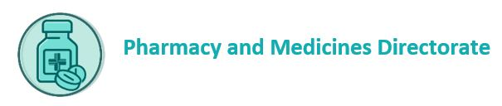
Patient Sharps Waste Container - Pre-Delivery Order Form

- Transport will automatically supply 30L sharps containers (blue and purple) and waste medicine containers on a one-for-one basis at the routine waste collection.

- An order must be placed for patient sharps containers in advance of your scheduled pick-up day. The transport team will only deliver pre-ordered containers and will not carry excess stock.

- An email will be sent to remind you the scheduled uplift is approaching.

- Please complete and email this form to: fife.transport@nhs.scot by 10.00am on the Monday before your notified waste uplift day to allow transport time to assemble orders.

Pharmacy Name:
Pharmacy Address:
Pharmacy Phone Number:

Sharps Container |  |  |  | Number Required  (ordered as single containers)
1L blue
5L or 7L blue
1L or 3L purple (cytotoxic/cytostatic)
5L or 7L purple (cytotoxic/cytostatic)
60L Griff Bins to collect patient container returns
NB: Sizes may vary due to stocks held
Date: |  | Print Name: |  |  | Sign:

