

A service level agreement for locally enhanced pharmaceutical care services

To deliver:

***INFLUENZA VACCINATION SERVICE FOR ELIGIBLE ADULTS\****

*[cmo-2024-10.pdf (scot.nhs.uk)](https://www.publications.scot.nhs.uk/files/cmo-2024-10.pdf)**Contents**

|  |  |  |
| --- | --- | --- |
|  | Section | Page |
|  | Contents | 2 |
|  | Preamble | 4 |
| 1. | Service Details, Commencement and Duration | 4 |
|  | Service Specification | |
| 2. | Introduction | 4 |
| 3. | Service Aims | 5 |
| 4. | Roles and Responsibilities | 5 |
| 5. | Service Outlines and Standards | 7 |
| 6. | Training | 8 |
| 7. | Premises | 9 |
| 8. | Service Availability | 10 |
| 9. | Vaccination Management Tool | 10 |
| 10. | Data Collection and Reporting | 11 |
| 11. | Stock Ordering | 11 |
| 12. | Payment Arrangements | 12 |
| 13. | Notification of Participation | 14 |
| 14. | Termination | 14 |
| 15. | Interpretation and Application | 15 |
| 16. | List of Appendices | 15 |
|  | Document Version Control | 16 |
|  | Appendices | |
| A. | Community Pharmacy Checklist | 18 |
| B. | VMT Guidance | 20 |
| C. | Vaccination Record (only to be used if VMT not available) | 26 |
| D. | Claim Form (only to be used if VMT not available) | 27 |
| E. | Participation Form | 28 |
|  | Patient Group Direction (separate document) |  |
|  | VMT Account Request (separate document) |  |
|  | **Inactivated Influenza Vaccine National Protocol v5 (August 2024) (separate document)** |  |

**A page has been set up on the CPD Team’s website which contains all information and supporting documentation relating to the provision of this service. Link below:**

[NHS Community Pharmacy Website (scot.nhs.uk)](https://www.communitypharmacy.scot.nhs.uk/nhs-ggc)

preamble

This Agreement (“**the Agreement**”) is between NHS Greater Glasgow & Clyde (NHS GGC), being a Health Board constituted pursuant to The National Health Service (Scotland) Act 1978 (as amended) (the **“Act**”) and having its headquarters at JB Russell House, Gartnavel Royal Hospital, 1055 Great Western Rd, Glasgow G12 0XH (the “**Board**”) and the Pharmacy Contractor named in the submitted Participation Form (**Appendix E**) (“**the Contractor**”) (each being a “**Party**” and being collectively referred to as “**the Parties**”).

1. SERVICE DETAILS, COMMENCEMENT AND DURATION

|  |  |
| --- | --- |
| 1.1 | This additional service will be operated by NHS GGC Community Pharmacies who sign up to participate, allowing Pharmacists and registered Pharmacy Technicians (where the Protocol has been adopted) to vaccinate their designated patient groups as a free NHS service. |
| 1.2 | This service is negotiated under [section 23 a (iii) Part 1 of the Scottish Drug Tariff](https://publichealthscotland.scot/services/scottish-drug-tariff/general-information-about-the-tariff/reimbursement/pharmaceutical-services-renumeration/) i.e. Pharmacy Contractors may enter into a contract with their local NHS Board in respect to provision of additional remunerated service. |
| 1.3 | This service has been developed as part of the Vaccine Transformation Programme (VTP). |
| 1.4 | This Agreement shall commence on **Tuesday 1st October 2024** (or shall be deemed to have commenced on) (“**the Commencement Date”)** and shall (subject to the other provisions of this Agreement) continue until **Sunday 31st March 2025** (“**Expiry Date**”) unless terminated in writing by either Party in accordance with clause 14.1. |

**SERVICE SPECIFICATION**

1. introduction

|  |  |
| --- | --- |
| 2.1 | This Service Level Agreement (SLA) acts as a contract between NHS GGC and the Pharmacy Contractor and commits the Pharmacy Contractor to provide the services as defined. The SLA must be read in conjunction with the Appendices provided. Services will be provided within the legal and ethical framework of pharmacy as a whole. |
| 2.2 | The vaccination is to be administered to eligible patients listed in [cmo-2024-10.pdf (scot.nhs.uk)](https://www.publications.scot.nhs.uk/files/cmo-2024-10.pdf). |
| 2.3 | Any eligible patient can have their vaccination administered via Community Pharmacy.  Community Pharmacy should focus on patients in the following cohorts:   * All those aged 65 and over; * All those aged 18 to under 65 in defined risk groups. This includes: * Those in clinical at risk groups set out in Green Book Chapter 19; * Those experiencing homelessness; * Those experiencing substance misuse; * Asylum Seekers living in Home Office hotel or B&B accommodation; * Pregnant women. |

1. SERVICE AIMS

|  |  |  |
| --- | --- | --- |
| 3.1 | The aims of this service are: | |
|  | a) | To administer a flu vaccination for eligible patients (see 2.3) who have not already received a flu vaccination in this year’s programme. |
|  | b) | To utilise the skills and expertise of highly trained healthcare professionals located in the widely distributed, accessible network of Community Pharmacies providing more opportunities and greater convenience for our patient cohort to obtain free NHS flu vaccinations and positively impact on the level of uptake. |

1. ROLES AND RESPONSIBILITIES

|  |  |
| --- | --- |
| 4.1 | **The Pharmacy Contractor will:** |
| 4.1.1 | Ensure they have read and fully understand the content of this SLA in order to follow the designated process. A checklist can be found at **Appendix A** of this document which Pharmacy Contractors might find useful. |
|  | Nominate a **Key Pharmacist** (usually the Responsible Pharmacist) **and technician/dispenser** who will have accountability for provision of each individual element of the service on a day to day basis from that pharmacy. For pharmacies open over extended hours and particularly on a Sunday, the Pharmacy Contractor must also ensure that the Locum/Relief manager and technician/dispenser on duty at these times has a full understanding of the SLA and Service Outline & Standards **(Section 5)** to be competent to maintain continuity of service. |
| 4.1.2 | Ensure the Standard Operating Procedures (SOPs) in place governing the service fully covers the main principles of the provision specific to the service standards operating within the pharmacy and that all involved in providing the service are fully conversant with the content of each SOP. |
| 4.1.3 | Ensure training of all Pharmacists and registered Pharmacy Technicians (where the Protocol has been adopted) providing vaccinations on behalf of the pharmacy is up to date and that support staff are aware of the service and which cohort of patients are eligible to access this service. Eligible patients are listed in [[cmo-20;/’242024-10.pdf (scot.nhs.uk)](https://www.publications.scot.nhs.uk/files/cmo-2024-10.pdf)](https://www.sehd.scot.nhs.uk/cmo/CMO(2022)19.pdf)  **Details of training requirements can be found at Section 6.** |
| 4.1.4 | Ensure that where they are utilising the Protocol to allow registered pharmacy technicians to participate in the service, that a copy of the appropriately signed Protocol is kept within the pharmacy for a period of eight years from the expiration of the Protocol (31st August 2025). |
| 4.1.5 | Ensure that all Pharmacists providing vaccinations under this service, on behalf of the pharmacy have confirmed that they have read, understood and accepted the professional responsibility associated with the NHS GGC PGD for the 2024/2025 Flu Service by completing CPDT’s e-form ([https://forms.office.com/e/41mAByUe1X](https://eur01.safelinks.protection.outlook.com/?url=https%3A%2F%2Fforms.office.com%2Fe%2F41mAByUe1X&data=05%7C02%7CManpreet.Narwan%40ggc.scot.nhs.uk%7C99a8b00d514b457f7ee708dc4d8816ce%7C10efe0bda0304bca809cb5e6745e499a%7C0%7C0%7C638470494082130205%7CUnknown%7CTWFpbGZsb3d8eyJWIjoiMC4wLjAwMDAiLCJQIjoiV2luMzIiLCJBTiI6Ik1haWwiLCJXVCI6Mn0%3D%7C0%7C%7C%7C&sdata=7ZZp64RJQJwo3hKpakAANe1qrrj8QkOdKow77GRZhqw%3D&reserved=0)) prior to their participation. |
| 4.1.6 | Make sure their team adheres to the requirements for the storage and supply of vaccines to ensure that the cold chain is maintained at all times. |
| 4.1.7 | Ensure they are familiar with the Vaccine Management Tool (VMT) recording system which will be used for recording patient consent, patient details and vaccination details. Full details can be found at **Appendix B.** |
| 4.1.8 | Ensure that they have taken into consideration provisions set out in the Health and Care (Staffing) (Scotland) Act 2019 so that the level of support available to operate the service is in line with the aims of the Act and that sufficient staff are available to safely and effectively provide the service. |
| 4.1.9 | Ensure that the Key Pharmacist and all pharmacy staff offer a user-friendly, non-judgmental, person-centred and confidential service. |
| 4.1.10 | Ensure that the services are operated from premises providing a level of confidentiality and privacy which is acceptable to the individual patient. |
| 4.1.11 | Ensure that all GPhC Standards are upheld during the provision of this service – in particular ensuring that vulnerable adults are safeguarded. |
| 4.1.12 | Participate in any local audit processes to the agreed levels. |
| 4.1.13 | Ensure that staff are provided with any updates or changes to the service. |
| 4.1.14 | Ensure that the service is available to patients for the full contracted opening hours of the premises unless there are exceptional circumstances e.g. emergency closure. |
| 4.1.15 | Ensure staff are appropriately trained and aware of the risks associated with the handling and disposal of clinical waste / bodily fluid spills and that correct procedures are used to minimise those risks. |
| 4.1.16 | Ensure that the pharmacy has a needle stick injury procedure. |
| 4.1.17 | An electronic copy of the SLA will be forwarded to the Participating Pharmacy Contractor each time the service is reviewed and agreed with Community Pharmacy GG&C (CP GG&C). The Participating Pharmacy Contractor (or nominated representative) will formally sign a copy of the SLA as a record of acceptance of the terms and conditions of the SLA for the provision of this additional service. The signed copy requires to be returned to **CPDT at: Pharmacy Services, Clarkston Court, 56 Busby Road, Glasgow, G76 7AT** by the date specified to ensure that all relevant payments can be made. Alternatively an electronic signed submission can be made to: [ggc.cpdevteam@nhs.scot](mailto:ggc.cpdevteam@nhs.scot). |
| **4.2** | **The Key Pharmacist will:** |
| 4.2.1 | Ensure the safe and effective provision of pharmacy services in line with GPhC Standard 9. |
| 4.2.2 | Maintain their competency to practice in this speciality by successfully completing all specified training requirements especially the mandatory element of this SLA **(Section 6).** |
| 4.2.3 | Ensure that all pharmacy staff providing the service maintain their competency to practice in this speciality and relevant staff successfully complete all specified training requirements, especially the mandatory element of this SLA **(Section 6).** |

1. service outlines and standards

|  |  |
| --- | --- |
| 5.1 | The service will be operational until the end of the flu vaccine season 2024/2025 or as directed by NHS GGC. |
| 5.2 | During the seasonal flu vaccination campaign period, pharmacy staff will identify people eligible for flu vaccination and encourage them to be vaccinated if they have not already been vaccinated in this flu season. This service covers the eligible patients as defined in [cmo-2024-10.pdf (scot.nhs.uk)](https://www.publications.scot.nhs.uk/files/cmo-2024-10.pdf) Community Pharmacies should focus on the cohorts described at Section 2.3 of this SLA above. |
| 5.3 | The seasonal flu vaccination to be administered under this service will be as indicated by the Scottish Government seasonal influenza vaccination programme 2024/2025. |
| 5.4 | Pharmacy Contractors must ensure that vaccinations offered under this service are provided in line with Immunisation Against Infectious Disease ([The Green Book](https://www.gov.uk/government/collections/immunisation-against-infectious-disease-the-green-book)), which outlines all relevant details on the background, dosage, timings and administration of the vaccination including disposal of clinical waste. |
| 5.5 | The Pharmacy Contractor must have an SOP in place for this service, which includes procedures to ensure cold chain integrity. All vaccines are to be stored in accordance with the manufacturer’s instructions and comply with [NHS GGC Vaccine Ordering, Storage and Handling Guidelines](https://www.nhsggc.org.uk/media/244993/vaccine-ordering-storage-and-handling-guideline.pdf). All refrigerators in which vaccines are stored are required to have a maximum/minimum thermometer. **Readings are to be taken and recorded from the thermometer on all working days in line with GPhC regulations**. NHS GGC recommends annual servicing of any fridge used for vaccine storage. The vaccines should not be used after the expiry date shown on the product. If a vaccine or cold chain incident occurs the Health [Protection Scotland Vaccine Incident Guidance](https://hpspubsrepo.blob.core.windows.net/hps-website/nss/2066/documents/1_vaccine-storage-handling-2017-12.pdf) should be followed. |
| 5.6 | Each patient being administered a vaccine should be given a copy of the manufacturer’s Patient Information Leaflet (PIL) about the vaccine. |
| 5.7 | Each patient will be required to confirm consent before being administered the vaccine. Pharmacy Contractors must use the consent statements set out in the VMT system to obtain the patient’s consent. The consent covers the administration of the vaccine. Patients should be advised about sharing the patient’s details with the GP Practice and NHS GGC. This notifies the patient of the information flows that may take place as necessary for the appropriate recording in the patient’s GP practice record and for the purpose of post payment verification by NHS GGC. |
| 5.8 | Where hard copy forms are used (because internet access is unavailable) details must be entered onto the VMT tool as soon as practicable and ideally within 24 hours of vaccination to ensure timely transfer of information to GP Practice systems. The forms should be retained for an appropriate period of time. As Pharmacy Contractors are the data controller, it is for each Pharmacy Contractor to determine what the appropriate length of time is. Decisions on this matter must be documented and should be in line with national and local policies. |
| 5.9 | The information contained in the VMT system will be shared with NHS GGC for the purposes of post payment verification and processing of service payments. |
| 5.10 | The Pharmacy Contractor must maintain appropriate records to ensure effective ongoing service delivery and post payment verification. |
| 5.11 | Where a patient presents with an adverse drug reaction following the initial vaccination and the Pharmacist believes this is of clinical significance, the patient’s GP practice should be informed, as soon as possible either via the GP Practice Notification Form (notification form can be found on the website – <https://www.communitypharmacy.scot.nhs.uk/nhs-ggc>or if that has already been sent to the GP practice, by an alternative method of communication. |
| 5.12 | The Pharmacy Contractor is required to record and report any patient safety incidents to **NHS GGC Public Health Protection Unit on 0141 201 4917** or PharmacyPublicHealth@ggc.scot.nhs.uk |
| 5.13 | The Pharmacy Contractor will ensure that the Key Pharmacist completes NHS GGC’s Cold Chain Audit preferably before the flu season starts but certainly before the end of the season. Failure to complete the module will result in a financial penalty (Para 12. ) |
| 5.14 | The Pharmacy Contractor is required to comply with arrangements that will be in place for the removal and safe disposal of any clinical waste related to the provision of this service. Further details of this will be provided in due course. |
| 5.15 | All parties will maintain patient confidentiality and comply will all relevant GDPR regulations. |
| 5.16 | The General Data Protection Regulation (GDPR) (EU) 2016/679 [13] and Data Protection Act 2018 [14] came into force on 25 May 2018. All organisations that process personal data are required to comply with the requirements of this legislation. |
| 5.17 | This means that personal information will be:   * Processed lawfully, fairly, and in a transparent manner. * Collected for specified, explicit and legitimate purposes. * Only collected so far as required for our lawful purposes. * As accurate and up to date as possible. * Retained for a reasonable period, in accordance with retention policies. * Processed in a manner which ensures an appropriate level of security. |
|  |  |

1. TRAINING

|  |  |
| --- | --- |
| 6.1 | The Pharmacy Contractor must ensure that all Pharmacists and registered Pharmacy Technicians (where the Protocol has been adopted) providing the service are competent to do so and have completed the necessary training. Pharmacists and registered Pharmacy Technicians (where the Protocol has been adopted) should demonstrate to the Pharmacy Contractor that they have the necessary knowledge and skills to provide the service. |
| 6.2 | The Pharmacy Contractor must ensure that Pharmacists and registered Pharmacy Technicians (where the Protocol has been adopted) providing the service are aware of the National Minimum Standards in relation to vaccination training, and are compliant with the training requirements within those Standards that apply to Pharmacists and registered Pharmacy Technicians providing the service. Pharmacists and registered Pharmacy Technicians (where the Protocol has been adopted) providing the service should undertake face-to-face training for injection technique and basic life support (including administration of adrenaline for anaphylaxis in line with National Standards). |
| 6.3 | The Pharmacy Contractor should ensure that they have reviewed **Section 5 - Service Outlines and Standards** and its associated documents. |
| 6.4 | The Pharmacy Contractor must ensure that staff are appropriately trained and made aware of the risks associated with the handling and disposal of clinical waste and that correct procedures are used to minimise those risks. A needle stick injury procedure must be in place. |
| 6.5 | The Pharmacy Contractor must ensure that staff involved in the provision of this service are advised that they should consider being vaccinated against Hepatitis B and be advised of the risks should they decide not to be vaccinated. The responsibility for providing access to Hepatitis B immunisation remains with the Pharmacy Contractor or employer. |
| 6.6 | The Pharmacy Contractor must ensure that their professional indemnity insurance is sufficient to cover this service. |
| 6.7 | Appointment times should be spread to minimise the need to hold patients in a waiting area within the pharmacy either pre- or post- vaccination especially in adhering to the requirement to monitor the patient for a few minutes after vaccination to ensure they suffer no adverse effects. |
| 6.8 | All vaccinators must make themselves familiar with the VMT User Guide and associated FAQs available on [TURAS](https://turasdashboard.nes.nhs.scot/). This is essential to ensure accurate recording of any vaccination administered. |
| 6.9 | Full information can be found at Section 5 of the CPDT Website - [here](https://www.communitypharmacy.scot.nhs.uk/nhs-ggc) |
|  |  |

1. PREMISES

|  |  |
| --- | --- |
| 7.1 | Under this service, vaccinations will be administered either within, or outwith pharmacy premises, in a suitable private area which must comply with the minimum requirements set out below:   * the area must be appropriate for private/confidential consultations; * The pharmacy must meet the General Pharmaceutical Council (GPhC) Standards for Registered Premises (if applicable) –   <https://www.pharmacyregulation.org/standards/standards-registered-pharmacies> |
| 7.2 | Vaccine waste should be consigned to the dedicated containers provided and set aside for collection by the specialist waste Contractor retained for this purpose. |
| 7.3 | A pharmacy checklist is available at **Appendix A.** |
| 7.4 | Procedures adopted to contain the COVID-19 infection as applicable at any time will require to be observed. Appropriate infection Control practices/procedures should be followed. For more information/Guidance see [National Infection Prevention and Control Manual: Home (scot.nhs.uk)](https://www.nipcm.hps.scot.nhs.uk/). Social distancing, regular hand washing and the use of sanitisers are recognised as good practice and are still likely to be required. The facility to regularly clean the clinical area must be built into the appointment schedule. |

1. SERVICE AVAILABILITY

|  |  |
| --- | --- |
| 8.1 | The Pharmacy Contractor must ensure the service is accessible, appropriate and sensitive to the needs of all service users. No eligible patient shall be excluded or experience particular difficulty in accessing and effectively using this service due to their race, gender, disability, sexual orientation, religion or belief, gender reassignment, marriage or civil partnership status. |
| 8.2 | The Pharmacy Contractor should seek to ensure that the service is available throughout the pharmacy’s contracted opening hours unless there are exceptional circumstances e.g. emergency closure. |
| 8.3 | The Pharmacy Contractor should ensure that locums or Relief Pharmacists are adequately trained, to ensure continuity of service provision across the opening hours of the pharmacy as far as possible. |
| 8.4 | For pharmacies open over extended hours the Pharmacy Contractor must also ensure that the staff on duty at these times are competent to maintain continuity of service. |
| 8.5 | If the pharmacy cannot offer the service at any given time then pharmacy staff must signpost patients by directing them to NHS GGC website:  [NHSGGC : NHS Greater Glasgow and Clyde - Homepage of our official site](https://www.nhsggc.org.uk/) |
| 8.6 | Where an appointment has been provided for the service every effort must be made to honor the appointment time. |
| 8.7 | The Pharmacist must not allow provision of flu vaccination to interfere with provision of other core pharmacy services from the premises. |

1. vaccination management tool (vmt)

|  |  |
| --- | --- |
| 9.1 | The Pharmacy Contractor must use the VMT to record the vaccination. |
| 9.2 | The majority of pharmacists should already have access to the VMT via their current TURAS log in details. |
| 9.3 | A registered Pharmacy Technician (where the Protocol has been adopted) involved in the provision of this year’s programme will need to have individual access to the VMT. Please see section 9.4 for details on how to apply for a username and password. |
| 9.4 | Should the pharmacy require additional Turas VMT user accounts set up, or if the pharmacy has not previously obtained Turas VMT accounts, then please complete the Turas VMT Account Request Form (separate document – Not An Appendix) and return to [ggc.cpdevteam@nhs.scot](mailto:ggc.cpdevteam@nhs.scot) supplying the following detail for each individual that requires access:   * Name * Email Address (if user has an existing Turas account then please supply the email address used for that account – if the user does not have a Turas account one will be created for them) * Designation within the practice i.e. GP/Nurse/Practice Manager/Administrator * Vaccination Management Tool Role   + Vaccinator - can register patients and record vaccinations   + Registrant – can only register patients |
| 9.5 | To access Turas VMT please use the following link - <https://vaccination.nhs.scot/> |
| 9.6 | Upon accessing Turas VMT the user will be prompted to select their Current Clinic**.** Each Community Pharmacy in NHS GGC has been created as an individual clinic within Turas VMT. To locate the practice clinic, click onto the clinic drop down list and enter the CP Contractor code into the **Search** box and confirm by selecting **Set My Current Clinic**. To select the clinic enter the letter “CP” then the “contractor code” into the search box and select your clinic. |
| 9.7 | The **Turas Vaccination Management User Guide** is available for download from within Turas VMT and can be accessed by selecting the **Help** menu and then **User Guides and FAQ’s** or via the following link - [User Guide Turas VMT](https://learn.nes.nhs.scot/40105/turas-vaccination-management-tool/user-guide) |
| 9.8 | Alternatively, abridged Guidance can be found at **Appendix B**. |

1. data collection and reporting

|  |  |
| --- | --- |
| 10.1 | The Pharmacy Contractor must maintain appropriate records to ensure effective ongoing service delivery. |
| 10.2 | All NHS influenza vaccines administered must be recorded using the VMT. |
| 10.3 | Vaccination events should be captured at the point of care. If you experience Wi-Fi or internet connection issues you can use a paper version of the patient’s vaccination record. This standard offline form for Turas Vaccination Management should be used in clinics where the vaccinator screens and vaccinates a patient. It includes space for the vaccinator to add their name, signature and professional registration number. An example form is available at **Appendix C**. The most up to date version can be accessed [here](https://learn.nes.nhs.scot/44703/turas-vaccination-management-tool/offline-forms). |
| 10.4 | Where record forms are scanned either into a patient’s notes or into a third-party data transfer software solution, care must be taken to ensure that the scanned copy is of a good quality and is a true copy of the original. |

1. stock ordering

|  |  |
| --- | --- |
| 11.1 | Pharmacy Contractors should use Movianto’s Marketplace portal to order vaccination stock - [Login (movianto.com)](https://marketplace.movianto.com/). |
| 11.2 | NHS GGC has set a cap on the number of vaccinations that can be ordered from Movianto as follows:  **QIVc**   * a maximum of 4 x packs of QIVc for the entire duration of the programme; and   **aQIV**   * a maximum of 2 x packs of aQIV for the entire duration of the programme. |
| 11.3 | * In the unlikely event that a participating pharmacy needs to order more than this allocation, a request should be made to [cpdt@ggc.scot.nhs.uk](mailto:cpdt@ggc.scot.nhs.uk). The request should contain: * Contractor Code; * Amount and type of stock required; and * Reason for request. |
| 11.5 | Each request will be considered individually and the Pharmacy Contractor advised of the outcome. Where the increase in allocation is approved, CPDT will advise NSS accordingly. |

1. payment arrangements

|  |  |  |
| --- | --- | --- |
| **12.1** | | **Payments for Service Participation/Delivery** |
| 12.1.1 | | The service will attract two payments:   * Participation/Training Grant (if applicable); * Vaccination Payment. |
| 12.1.2 | | On receipt of a “properly completed” Participation Form, the CPDT will make payment of **£350.00 to Pharmacy Contractors who haven’t already received the full payment in 2023/2024.** This payment should cover training fees, any initial set up costs and ongoing collation of information relating to the service. |
| 12.1.3 | | On receipt of a “properly completed” Participation Form from a Pharmacy Contractor who received the full Participation/Training payment in 2023/2024, the CPDT will make payment of £150.00. This payment should cover training fees. |
| 12.1.4 | | Where a Participation Form is not considered to be properly completed, the CPDT will return the form to the Pharmacy Contractor with a request for proper completion, providing a full explanation of remedial action required. No payments will be made pending receipt of form. |
| 12.1.5 | | Payment claims for the vaccination element of this service will be generated electronically via the VMT system. This will generate payment automatically and no paper claims are required. There is a claim form in **Appendix D** should VMT become unavailable for any reason. |
| 12.1.6 | | Payment will be in line with the fee structure for other Pharmacy Contractors, currently **£8.75** per administered dose of vaccine to cover the costs of the service. The vaccines to be used will be ordered via Movianto. Additional costs related to use of alternative vaccines will not be paid unless by prior agreement with NHS GGC and in line with National Guidance. |
| 12.1.7 | | In the event that a paper claim form is needed: Claim Forms received by the 5th in the month, will be processed and payment made in that month i.e. a properly completed claim form received on 4th November will be paid at month end November via dispensed September, paid November payments. |
| 12.1.8 | | The payment set out in 12.1.2 and 12.1.3 are outwith the scope of VAT. |
| 12.1.9 | | The payment set out in 12.1.6 is VAT exempt. |
| 12.1.10 | | The Payments set out in 12.1.2, 12.1.3 and 12.1.6 are exclusive of any applicable Value Added Tax.  Value Added Tax will be charged at the prevailing rate and is payable by NHS GGC following the receipt of a VAT invoice. |
| **12.2** | | **Overpayments/Recoveries** |
| 12.2.1 | | If an over/inappropriate payment is identified, the CPDT will make arrangements to process a recovery.  The payment recovered will not exceed the amount of the over/inappropriate payment.  No additional/further financial sanction will be applied. The Pharmacy Contractor will be advised of the intention to recover monies before the recovery is made. |
| 12.2.2 | | Pharmacy Contractors signing up to provide this service do so on the basis that they will provide at least 25 vaccinations. Any participating not recording 25 or more vaccinations on VMT will be required to repay the training/set up element of the financial package **(see Paras 12.1.2 and 12.1.3)**. |
| 12.2.3 | | Any recovery will be made via the Regional Payments process and will be visible both via the PAY001 produced by Practitioner Services Division (PSD) and the local remittance produced by the CPDT. |
| 12.2.4 | | The Pharmacy Contractor will be advised of the intention to recover monies before the recovery is made. |
| **12.3** | | **General Business Costs** |
| 12.3.1 | | General business costs such as insurance, servicing finance, banking charges, business administration, payment tracking etc. are reflected in national arrangements for community pharmaceutical services and as such do not form part of local arrangements/ Service Level Agreements. |
| 12.3.2 | | It is anticipated that the products prescribed and supplied via Community Pharmacy under this SLA will be available from AAH wholesalers through existing account arrangements and will require no, or minimal additional workload, around account set up, payment tracking, administration etc. |
| **12.4** | **Risk** | |
| 12.4.1 | Pharmacy Contractors will remain accountable for delivery of their professional responsibilities and standards e.g. incorrect ordering of a medicine would fall beneath the threshold at which a Board / prescriber would be expected to take financial responsibility, although NHS GGC will where possible attempt to utilise such medication for alternative patients. | |
| **12.5** | **Service Financial Management** | |
| 12.5.1 | The CPDT will undertake post-payment verification checks in line with the process established and agreed via National Services Scotland. Pharmacy Contractors participating in the service should support this exercise by providing information if requested. | |
| **12.6** | **Sanctions** | |
| 12.6.1 | Failure to return a completed SLA within 3 months of commencement of service will result in any payment associated with the service being withheld until it is received. | |
| 12.6.2 | Failure to complete NHS GGC’s Cold Chain Audit by March 2025 will result in recovery of a portion of the payment made under Para 12.1.2 or 12.1.3. This portion to be agreed between CPDT and CP GGC. Section 12.2 describes arrangements governing Overpayments/Recoveries. | |

1. notification of participation

|  |  |
| --- | --- |
| 13.1 | Pharmacy Contractors should indicate their willingness to participate in the service by submitting a signed copy of the Participation Form (**Appendix E**). Forms should be submitted via e-mail [ggc.cpdevteam@nhs.scot](mailto:ggc.cpdevteam@nhs.scot) . |
| 13.2 | NHS GGC reserve the right to decline a pharmacy under this SLA. |

1. termination

|  |  |
| --- | --- |
| 14.1 | Should either party require to terminate this arrangement, they will only do so after providing written notification to the CPD Team. |
| 14.2 | Pharmacy Contractors should endeavour to provide reasonable notice of their intention to withdraw from the service, to allow alternative arrangements to be made for any patients who may have an expectation of receiving the service. |
| 14.3 | Pharmacy Contractors should e-mail notification of withdrawal to: [ggc.cpdevteam@nhs.scot](mailto:ggc.cpdevteam@nhs.scot) |
| 14.4 | Where there are issues of performance, or compliance, the Board will work with the Pharmacy Contractor to resolve these and will provide the Pharmacy Contractor reasonable time to make any improvements identified. |
| 14.5 | Where the Board requires to terminate a Pharmacy Contractor’s participation in the service, or the service itself, it will endeavour to provide no less than four weeks notice to the individual Pharmacy Contractor or the community pharmacy network as a whole. |
| 14.6 | The Board will provide notification of termination either via the established communication route (Communications Updates direct to the individual pharmacy’s clinical mailbox) or (in the case of national multiples) to the commissioning address provided with the Participation details. |

1. INTERPRETATION AND APPLICATION

|  |  |
| --- | --- |
| “the Act” | Means the National Health Service (Scotland) Act 1978 |
| “Board” | Means a Health Board within the meaning of section 2(1)(a) of the Act |
| “Contractor” | Means a person whose name is included on a Board’s Provisional Pharmaceutical List or Pharmaceutical List |
| “Commencement Date” | Means the date on which the service will begin and the date on which claims for payment will be deemed to be appropriate |
| “Expiry Date” | Means the date on which the service will end or the date by which the Service Level Agreement will be reviewed and renewed |
| “Extended Hours” | Means pharmacies open after 6.00pm on weekdays (at least one in the week), after 1.00pm on Saturday or any time on Sunday |
| “GDPR Regulations” | Means the EU General Data Protection Regulation 2016/679 as retained by UK law under the European Union (Withdrawal) Act |
| “Parties | Has the meaning assigned to it in the Preamble to this Service Level Agreement |
| “properly completed” | Means the form must contain: Contractor code, authorised signature, date of signing and completion of any other information deemed necessary. |
| “Protocol” | Means the national Protocol for the supply and administration of Inactivated Influenza Vaccine by appropriately trained persons in accordance with Regulation 247A of the Human Medicines Regulations 2012, as inserted by The Human Medicines (Coronavirus and Influenza) (Amendment) Regulations 2020. |
| “reasonable notice” | Means in all normal circumstances no less than 21 calendar days. |
| “the Regulations” | Means the National Health Service (Pharmaceutical Services) (Scotland) Regulations 2009 as amended |

1. LIST OF APPENDICES

|  |  |
| --- | --- |
| **Appendix A** | Pharmacy Checklist |
| **Appendix B** | VMT Guidance |
| **Appendix C** | Vaccination Record (only to be used if VMT not available) |
| **Appendix D** | Claim Form (only to be used if VMT not available) |
| **Appendix E** | Participation Form |
| **Separate Document** | Patient Group Direction |
| **Separate Document** | VMT Account Request |
| **Separate Document** | **Inactivated Influenza Vaccine National Protocol v5 (August 2024)** |

|  |  |
| --- | --- |
| **Version** | **7. Updated SLA** |
| **Name/Department of**  **Originator/author:** | Community Pharmacy Development Team |
| **Name/Title of responsible**  **Committee/individual:** | Alan Harrison, Lead Pharmacist Community Care |
| **Date issued:** | 13th September 2024 |
| **Target audience:** | NHS GGC Community Pharmacy |

|  |  |  |
| --- | --- | --- |
| **Version** | **Date** | **Control Reason** |
| 6. | September 2024 | * Annual Review and update to reflect this year’s eligible cohorts; * Inclusion of mandatory requirement to complete Cold Chain Module on Learnpro; * Inclusion of financial penalty of non completion of module. |
| 5. | September 2023 | * Annual Review and update to reflect this year’s eligible cohorts; * Vaccination fee amended to reflect uplift; * Section 12.1.8 added |
| 4. | September 2022 | 4. Section amended and renumbered to include detail on retention of signed Protocol;  6.8 – Reference to dedicated TURAS VMT training module deleted;  6.9 – Link to CPDT website inserted  9. – Section amended and renumbered to include reference to registered technicians;  11.3 – Clarification of Quota arrangements; |
| 3. | August 2022 | 1.4 – Amended to reflect correct day;  2.4 – Amended to provide clarification of arrangements for 16-18 in school cohort;  5.12 – Amended to allow submission of patient safety incident information by e-mail  11.3 – Removal of weekly quota and addition of monthly quota;  Clarification of arrangements for authorisation.  14. – Amended to provide more detail  15. – Definition of GDPR Regulations expanded |
| 2. | July 2022 | Updating of links |
| 1. | July 2022 | Amendment to wording around maximum stock ordering |

**Appendix A**

## NHS GGC Flu Vaccination Service -Community Pharmacy Checklist

This checklist serves to act as an aide memoire to support your participation:

* All vaccinators

|  |  |
| --- | --- |
|  | competent to deliver immunisation |
|  | has read and completed relevant sections of the National Protocol for Inactivated Influenza Vaccine |
|  | has completed immunisation training and signed self – declaration |
|  | has had required training in CPR and anaphylaxis |
|  | has appropriate occupational immunisations |
|  | is competent with standard hand hygiene procedures |
|  | has read the SPC for the product(s) |
|  | have access to the VMT |

* Product

|  |  |
| --- | --- |
|  | product is fit for use |
|  | recommended flu vaccines available |

* Resources

|  |  |
| --- | --- |
|  | copies of the National Protocol for Inactivated Influenza Vaccine are available |
|  | copies of standard reference texts are available |
|  | a telephone is available |
|  | PPE is available |
|  | vaccine supplies and sharps bins are available |
|  | Standard Operating Procedures for cold chain/ fridge monitoring and vaccine incident management |
|  | Adrenaline / Epinephrine is available |

* Premises

|  |  |
| --- | --- |
|  | A private clinical area is available |
|  | A pharmaceutical grade refrigerator is used to store vaccine |
|  | Hand cleaning facilities are available |
|  | The cleanliness of the clinical area is maintained |

Version 1 - January 2022

Reproduced from original developed by NHS Lothian

**Appendix B**

**VMT Help Guide - Vaccinator (register, screen & vaccinate a patient)**

* **On your initial login you will be asked to enter your registration number.**
* **Then select your current clinic – this is your Pharmacy.**

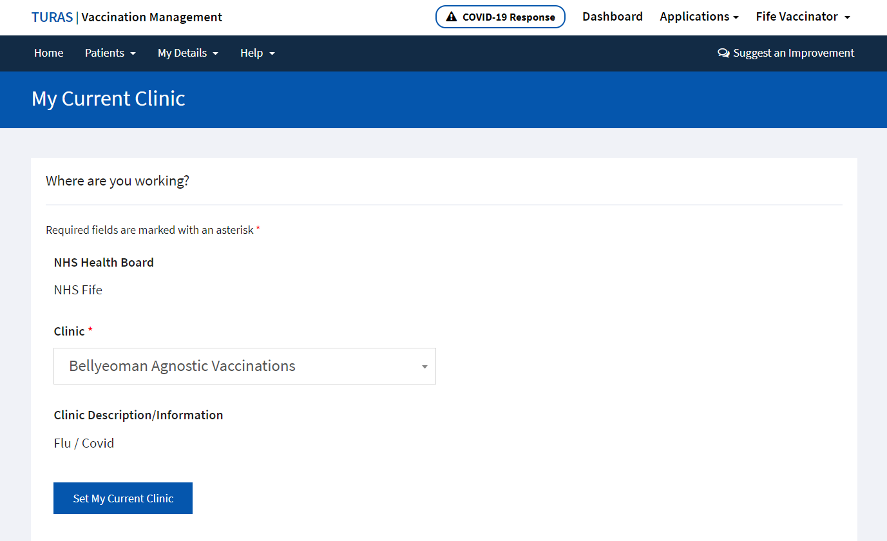

* **Select yes to confirm**

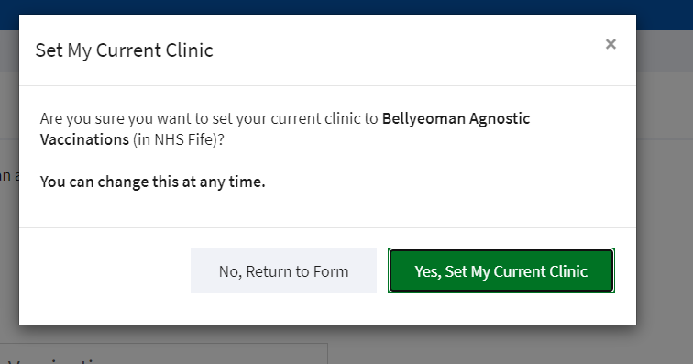

1. **Register a Patient**

* **Go to homepage**

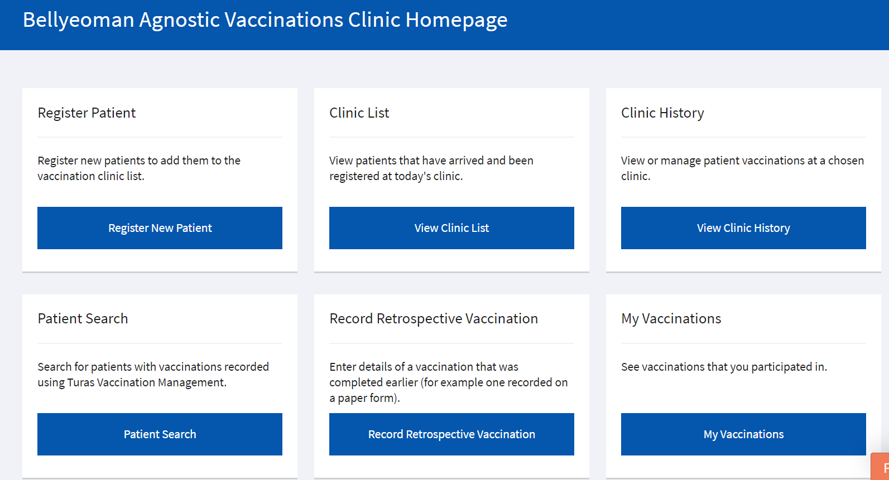

* **and select register patient**

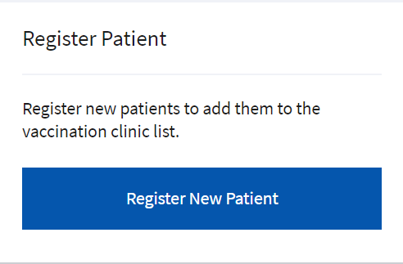

* **Search for patient by either entering patients CHI or Search by Patient Details (DOB, last name & first name). The use of CHI is preferable as demographics will be populated for you. Fields with red * are mandatory.**

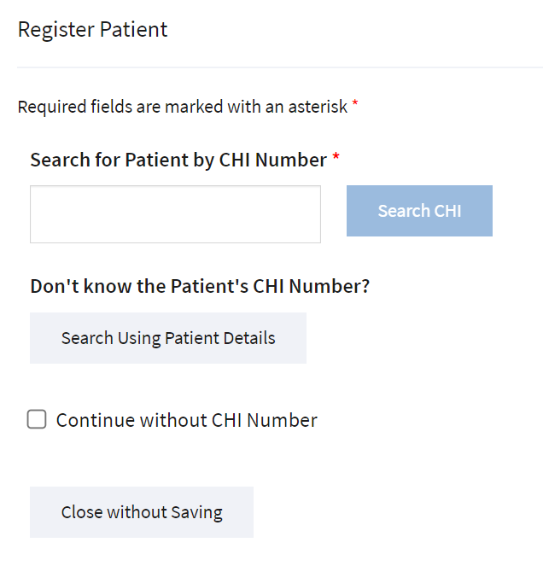

* **Confirm CHI search results & select patient**

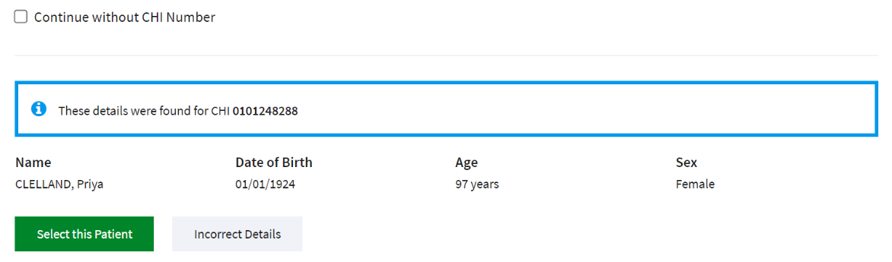

* **Select vaccination type & eligibility criteria**

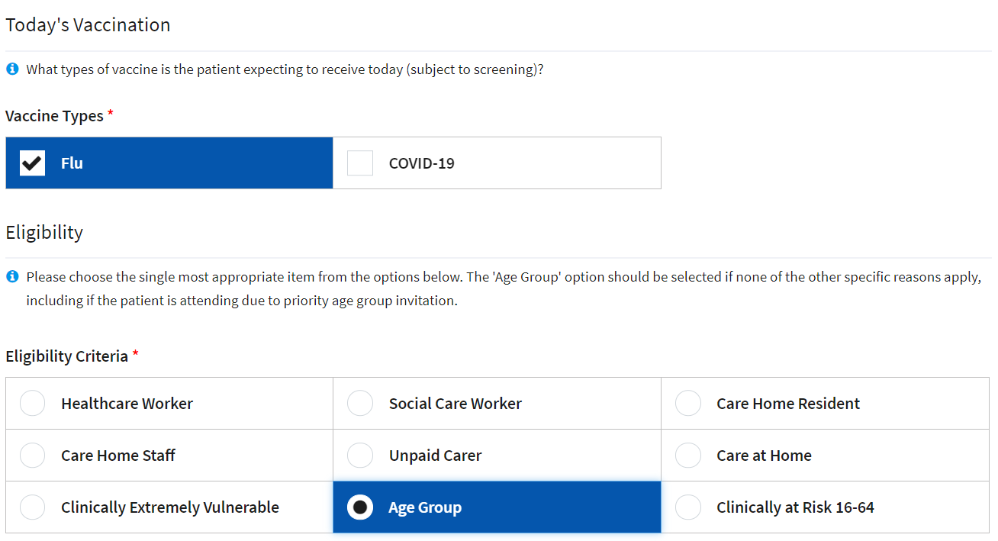

* **Select no to appointment clinic**

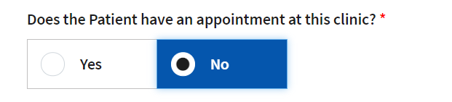

* **Select register patient & start screening**

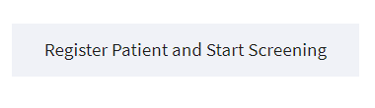

* **Confirm details**

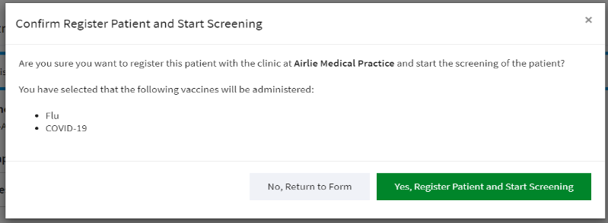

1. **Screening & Consent**

* **If yes, you will be prompted for details.**

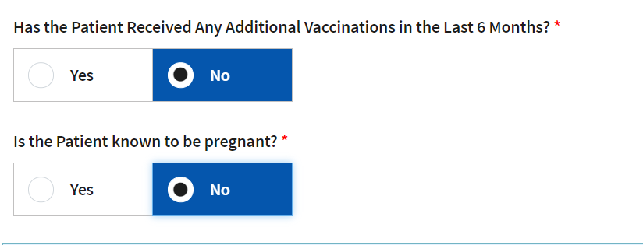

* **Select suitability & consent for Flu**

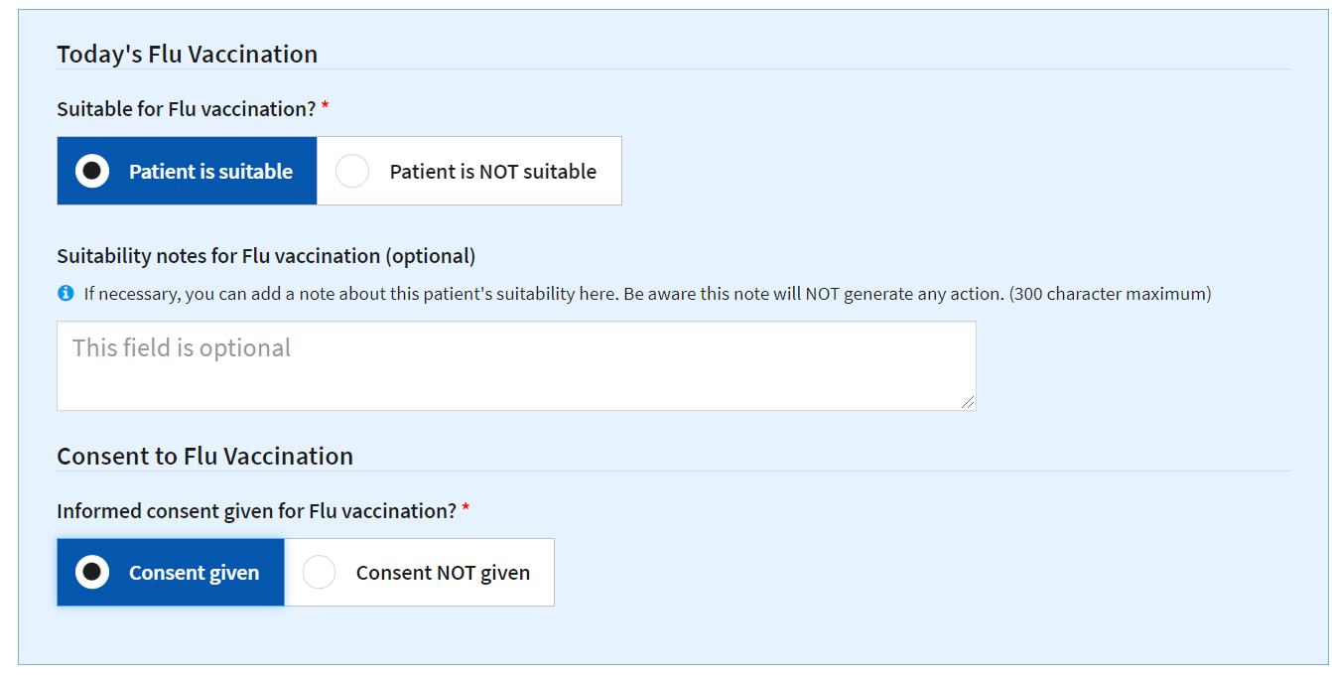

* **Record Screening Outcome & Start Vaccination**



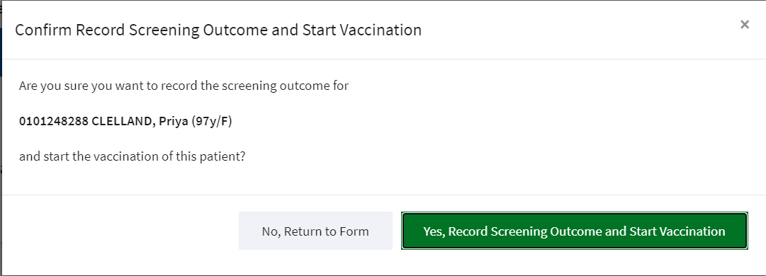

1. **Record Vaccination**

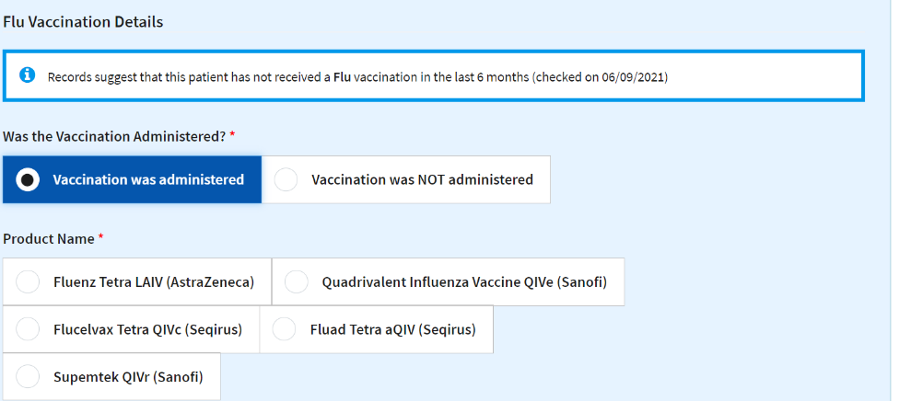

**N.B. Product name selected will provide differing methods of administration**

* **Select product & batch**

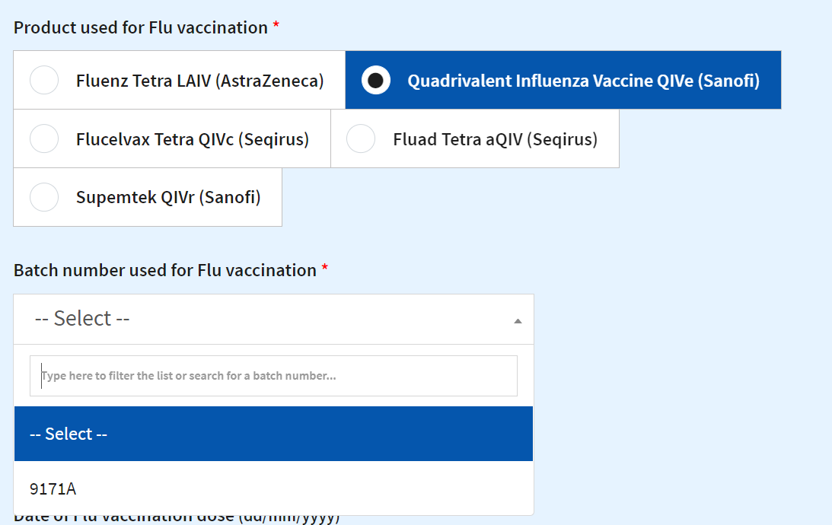

* **Enter dose, date, method & site**

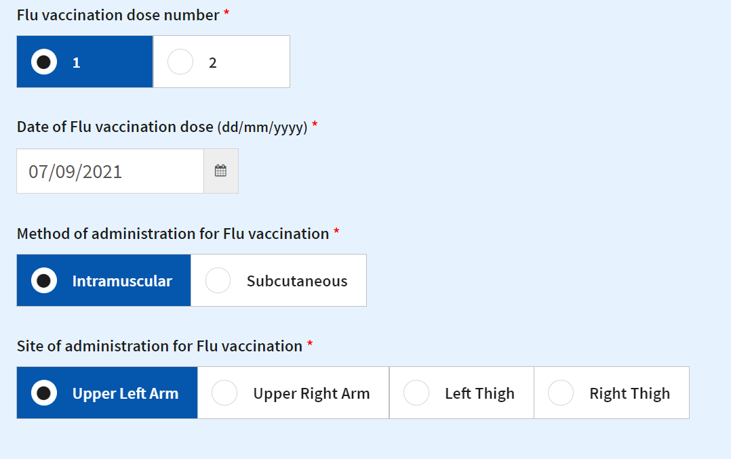

* **Complete Post Vaccination Check & Finalise the vaccination record.**

**IMPORTANT: Please ensure all vaccination details are correct before confirming vaccination.**

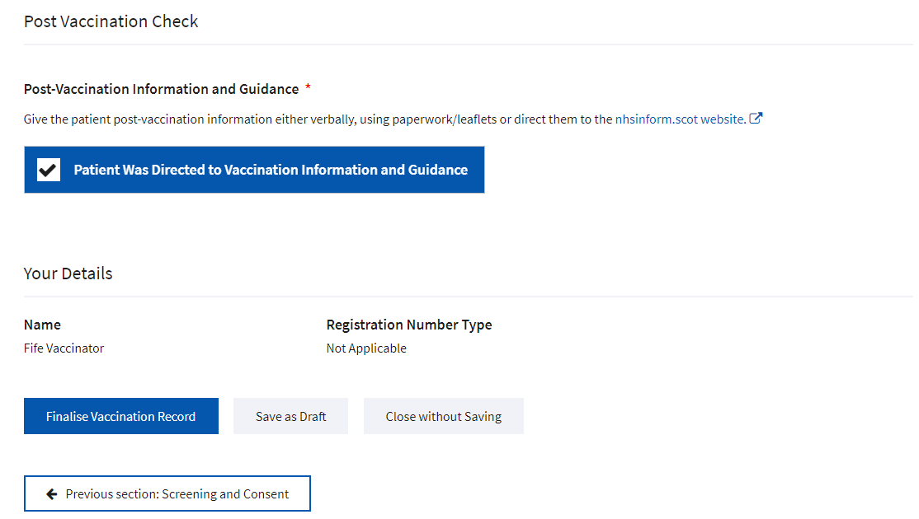

* **Confirm Vaccination**

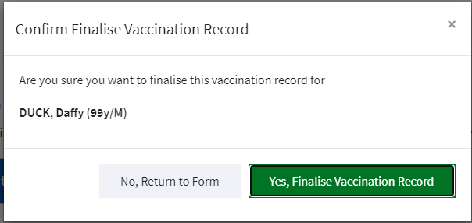

* **Go back to home page to register another patient. (You may be asked if using the same batch numbers and previous batch details will be populated).**

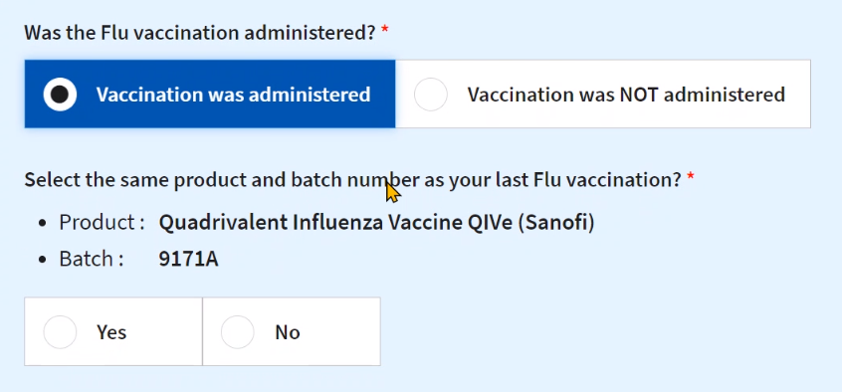

**If you discover an error has been made, you have up to 60 minutes to amend the vaccination details.**

* **Click on Home to take you Home Page**

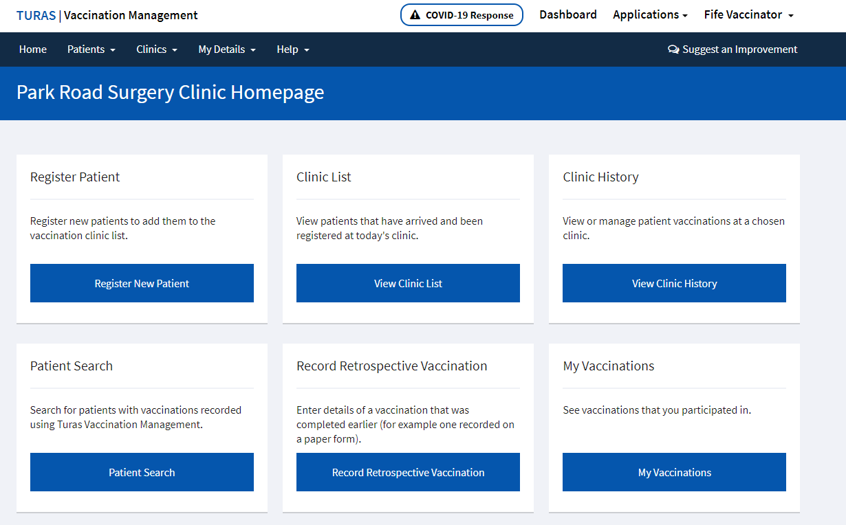

* **Click on view clinic list and filter list on Completed Today**

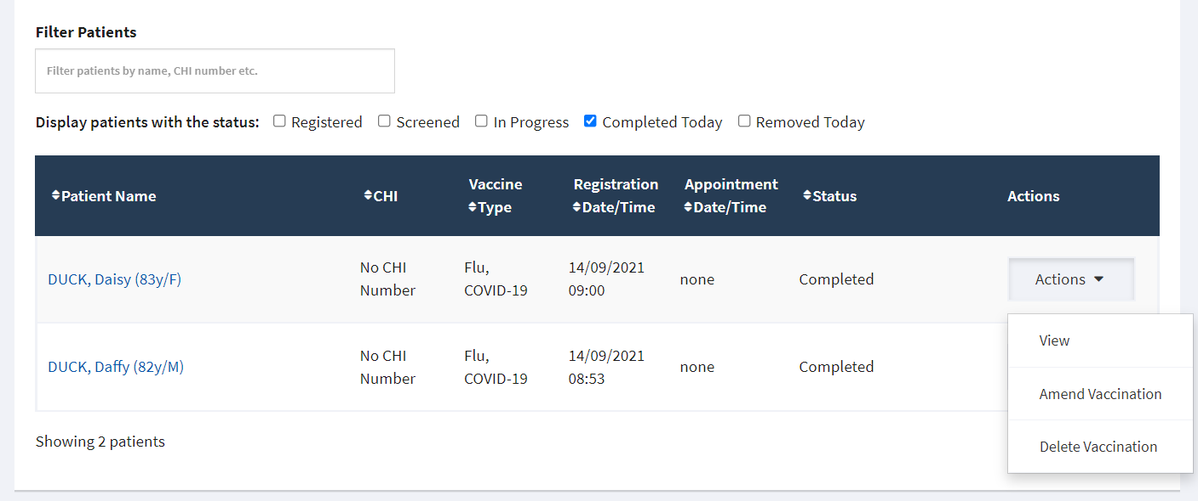

* **Select patients’ actions and click on Amend Vaccination.**

**Any patients who need amended thereafter will need to be done by contacting** [**cpdt@ggc.scot.nhs.uk**](mailto:cpflu@nhslothian.scot.nhs.uk) **in the first instance.**

* **Please ensure you sign out of clinic when you have completed your vaccinations.**

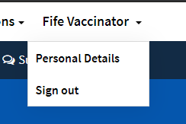

**You will be warned if you have any outstanding vaccinations.**

**Appendix C: NHS Community Pharmacy Seasonal influenza Vaccination Service - Record of administration of flu vaccination and consent (only required if VMT not available)** V7.0 16/06/2021

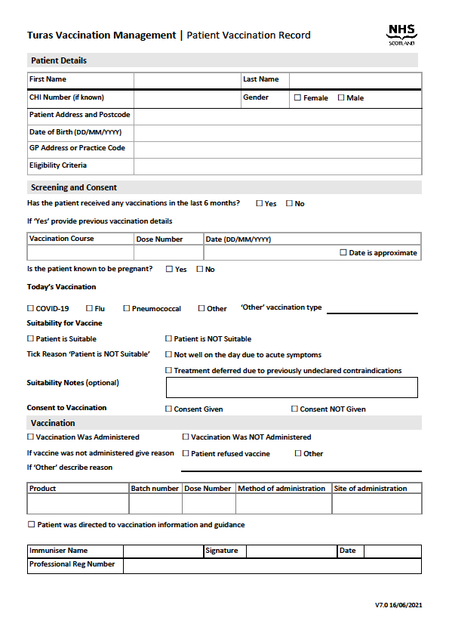

**Appendix D: Flu Vaccination Service Claim Form (only to be used if VMT not available)**

**NHS GGC COMMUNITY PHARMACY CLAIM FORM**

**INFLUENZA IMMUNISATION SERVICE**

**Contractor Code:**

**Section A – Immunisations administered for the month of**

**Number of claims submitted for**

|  |  |
| --- | --- |
| Influenza vaccination **TOTAL** |  |

**Payment**

Fee applicable as per any national remuneration package

**Claims should be submitted by the 1sth of the month to:**

*ggc.cpdevteam@nhs.scot*

I declare that the information I have given on this form is correct and complete and I understand that if it is not, action may be taken against me. I acknowledge that my claim will be authenticated from appropriate records, and that payment will be made to my Pharmacy, which will be subject to Payment Verification. Where the Community Pharmacy Development Team is unable to obtain authentication, I acknowledge that the onus is on me to provide documentary evidence to support this claim.

**Signed by** .........................................................

**Date** ..................................................................

**Pharmacy Stamp**

**Appendix E**

**SLA Declaration of Participation:**

|  |  |  |
| --- | --- | --- |
| Community Pharmacy Stamp or Address: |  | Contractor Code: |
|  |  |  |
|  |  |  |
|  |  |  |

Please complete and return this form to:

|  |  |
| --- | --- |
| Community Pharmacy Development Team |  |
| Clarkston Court, 56 Busby Road | E-mail to: [ggc.cpdevteam@nhs.scot](mailto:ggc.cpdevteam@nhs.scot) |
| Clarkston |  |
| Glasgow |  |
| G76 7AT |  |

**Agreement to Provide:**

Flu Vaccination Service to eligible patients between **1st October 2024 and 31st March 2025**.

Pharmacy Contractor/Pharmacy Contractor Representative Name:

……………………………………………………………………………………. (*Please print)*

Signature: …………………………………………. Date: …………………..

|  |
| --- |
| **Counter Fraud Declaration**: I accept that the information provided on this form may be used to verify any claim associated with this service and may be shared with other bodies/agencies for the purposes of prevention and detection of crime.  In signing this form, I consent to this use and acknowledge that if I provide false information then I may be liable to criminal prosecution, referral to my professional body and/or recovery proceedings. |

Please sign this document and retain for your own records. Please submit a copy as above.

**Signed on behalf of NHS Greater Glasgow & Clyde:**



**Date: 12th September 2024**