Buvidal® Community Pharmacy Administration
Standard Operating Procedure

Contents

A. Community Pharmacy Participation Requirements
B. Receipt of the prescription and Patient Specific Direction (PSD)
C. Pre-injection Process
D. Administration of Buvidal®

Appendix 1: Consent Form (from service)
Appendix 2: Flow chart of process
Appendix 3: Prescribing Responsibilities: Substance Use Service (SUS)
Appendix 4: Prescribing Responsibilities: Community Pharmacist Independent Prescribers
Appendix 5: Sample Post Administration Email to Prescribing Service
Appendix 6: Buvidal Administration Taken from section 6 of SmPC

- Community Pharmacy Participation Requirements:

- Community Pharmacies will deliver the service in line with the accompanying Service Level Agreement (SLA)
- Ensure they have the required equipment for administration of Buvidal®:
- Patient’s dispensed Buvidal® dose
- Gloves or NHS handwashing instructions and PPE use as per current guidance
- Swabs, cotton wool and plasters
- Sharps bin
- Anaphylaxis kit (and be trained in its use as per SLA):
- Adrenaline 1:1000 (1mg/1mL) vials
- 5 x 1mL syringe
- 5 x 25mm blue (23G) needles
- 1 x Pocket mask
- Buvidal® is a schedule 3 controlled drug (CD). CD prescription requirements and safe storage regulations apply.

- Receipt of the prescription and Patient Specific Direction (PSD):

- A Pharmacist will undertake the standard clinical review (including a check of GP prescribed medication using ECS) and accuracy checks of the prescription and PSD and ensure stock is ordered. Where any issues are identified with the prescription or documentation they will contact the prescriber to discuss.
  - The PSD should include
    - Patient’s details: name, and CHI and contact number as a minimum
    - Buvidal® strength, dose, frequency (weekly or monthly) and expiry date of PSD
    - Prescriber’s details: name, registration number if NMP and service name
    - Pharmacy name
- If the prescriber is a pharmacist who works within the administering pharmacy the clinical review and accuracy check should be undertaken by a separate, suitably qualified healthcare professional
- Confirm date next Buvidal® injection is due, as noted on the PSD provided by the SUS prescribing service. Confirm this date with patient and make appointment
- Confirm that the patient has consented to administration of Buvidal® by the pharmacy and information sharing as outlined in the consent form (Appendix 1) completed with the Buvidal® prescriber.
- Seek consent from the patient on each occasion before accessing the patient’s ECS.

- Pre-injection Process:

- Confirm dose due within window period for administration (+/- 2 days for weekly doses, +/- 7 days for monthly doses)
- If there are any concerns regarding suitability to issue the dose contact keyworker/prescriber prior to giving dose
- Check patient:
  - identity. Ask them to confirm their name and date of birth. Check that it corresponds with the prescription PSD and dispensed medication
  - understands the long-acting nature of the product and is aware of adverse effects (provide and use Buvidal® patient information leaflet-available from: Buvidal | Buprenorphine - Prolonged release solution for injection
  - history of allergy, previous reaction or adverse effect with buprenorphine, Buvidal® or its excipients
  - Is expecting Buvidal® injection at the prescribed dose and strength
- Check how the patient has been since last dose e.g. any injection site reactions/issues, cravings or continued illicit use with potential for harm.
- Check if there has been any changes to prescribed or OTC medicines since last Buvidal® administration
- Check the dispensed drug and dose against the PSD, ensure the PSD is still valid
- Check the expiry date of medicine. Record batch number and expiry on the patient’s administration record
- Check the patient administration record for date of last administration, injection site and any previous issues.
- Let the patient know that Buvidal® is to be administered by the subcutaneous route and confirm which site on the body the patient would prefer. Injections should be rotated in preferred site(s) (buttock, thigh, abdomen, or upper arm). The same injection site should not be used more than once in an 8 week period and injections on the waistline or within 5cm of the navel should be avoided.
- Confirm patient consent for administration of Buvidal®
- Withhold the dose and contact prescriber / clinical key worker without delay where:
  - contra-indications to the prescribed medication are discovered or assessment of the patient indicates that the medicine is no longer suitable
  - the patient attends intoxicated or other concerns are raised
  - the patient has missed the window period for administration (+/- 2 days for weekly doses, +/- 7 days for monthly doses)

- Administration of Buvidal®

- Undertake hand washing procedure and put on gloves
- Clean site with a sterile alcohol wipe
- Inject into the site as per manufacturer’s guidance (Appendix 6)
- Dispose of injection in the blue topped sharps bins per NHSG clinical waste guidance
- Wipe injection site with cotton wool, put on plaster if necessary
- Remove gloves if used and dispose with cotton wool in clinical waste
- Monitor patient for 10 minutes after administration of first dose or changing between weekly and monthly preparations to assess for adverse reaction
- Ensure patient
- receives information regarding side-effects including pain and inflammation at the injection site
- knows to report back any side-effects or problems to the pharmacy, keyworker or prescriber
- has and carries a Buvidal® patient alert card. Encourage patients to show this to other health care professionals if they need any kind of medical treatment
- knows details of future appointments. It is advisable that the pharmacy has a system for reminding patients
- Record administration including the site used on the administration record
- Ensure that the PSD remains valid for next injection. If PSD is due to expire ensure a new PSD is provided by the SUS prior to next due administration date
- Email the prescribing service after each injection either by ad hoc email (see sample Appendix 4) or by attaching the administration record and sending for the attention of the key worker.

Service generating prescriptions | Email Address
Timmermarket Clinic | gram.timmermarket@nhs.scot
Fulton Clinic | gram.fultonenquiries@nhs.scot
North Aberdeenshire drug and alcohol teams | gram.kessockclinic@nhs.scot
South Aberdeenshire drug and alcohol teams | gram.southcentralsms@nhs.scot

- Report adverse reaction to Buvidal®, SMS pharmacists and the Medicines and Healthcare Products Regulatory Agency (MHRA) via the “Yellow Card” scheme

Patient Name |  | CHI
Pharmacy Name

Patient: Requirements of Treatment

I agree to:
  - Administration of Buvidal® by the community pharmacy named above
  - The sharing/discussion of necessary personal information between the prescribing service, named community pharmacy and GP (if different) to enable safe prescribing and administration of Buvidal®
  - Provide up to date contact details and let the service know if they change
  - Keep agreed appointments with the prescribing service (in person or by phone)

Staff Responsibilities
I have discussed the following with the patient or checked medical records:

- The different opioid replacements (ORT) available to ensure that Buvidal® is currently the best option for them.
- Other patient diagnoses and allergies to identify cautions or contraindications
- Key information in the Buvidal® patient leaflet.
  - Starting treatment and avoiding precipitated withdrawal
  - Form: subcutaneous injection, site selection/rotation, local injection site reactions
  - Long acting nature and frequency (weekly and monthly)
  - Missed doses/flexibility in dosing (+/- 2 days for weekly, +/- 7 days for monthly)
  - They can ask to stop treatment/switching to a different ORT if needed
  - Common adverse reactions of Buvidal®. Reporting to staff and how to respond
  - Overdose awareness, harm reduction and naloxone
- That patients cannot pick up and self-administer Buvidal®. This form consents to administration of Buvidal® by the named pharmacy.
- Importance of GP and hospital knowing you are on Buvidal® when pain relief is needed

The patient has confirmed to me that they understand the information discussed, have been provided with printed patient information and wish to proceed with treatment.
All necessary consents have been agreed.

Staff Name |  | Date

Responsibilities of the Prescribing Service

- Identify suitable patients and obtain informed consent for treatment and to sharing of relevant data and contact details with community pharmacy administration site

- Confirm with patients that there is still a requirement to maintain agreed appointments with specialist SMS in addition to pharmacy administration appointments

- Maintain communication links with pharmacy and ensure the pharmacy has clear contact details for the prescriber and any other keyworker(s) involved in the patient’s package of care

- Generate and send prescriptions and Patient Specific Directions (PSD) to the chosen pharmacy

- Undertake ongoing clinical reviews of the patient and adjust treatment according to patient response and assessment, monitoring and feedback provided by the community pharmacy

- Provide update letter to patient’s GP advising them that Buvidal® is being prescribed and request that it is recorded in the patient’s GP record as prescribed by another service in line with Grampian Guidance for Recording Medicines Originating in Secondary Care by General Practices (1)

- In the rare eventuality that the pharmacy cannot undertake injection SMS may be require to support the pharmacy to ensure treatment continues.

- Have read and understood current NHSG guidance on the use of Buvidal®. Pharmacists will prescribe Buvidal® as per NHSG guidance
https://www.nhsgrampian.org/globalassets/services/medicines-management/policies/guide_buvidal.pdf
- Understands the pharmacology of Buvidal®. Can identify: Cautions, contraindications, adverse effects and drug interactions)
- Can discuss and compare all Opioid Substitution Treatments (OST) options to support patient selection of appropriate medication
- Understands and can discuss the administration schedule of Buvidal® when initiating, titrating, maintaining, switching and stopping the product.
- Identify potential patients and present case at local integrated alcohol and drug service hub or for confirmation of suitability
- Obtain informed consent to treatment and administration
- Obtain informed consent to share and/or discuss prescribing information with the prescribing service and the patient’s GP (if different) for the purposes of safe and effective prescribing
- Obtain informed consent to access the patient’s ECS on each occasion that this is required
- Generate prescription and PSD for administration
- Ensure that a registered healthcare professional other than the prescribing pharmacist participates in the clinical and accuracy checks during dispensing and administration processes to minimise risk of error (RPS - Medicines, Ethics and Practice)
- Document details of each consultation and the current treatment plan
- Provide update letter to patient’s GP advising them that Buvidal® is being prescribed and request that it is recorded in the patient’s GP record as prescribed by another service. A copy should be sent to the patient’s prescribing service if not the GP.
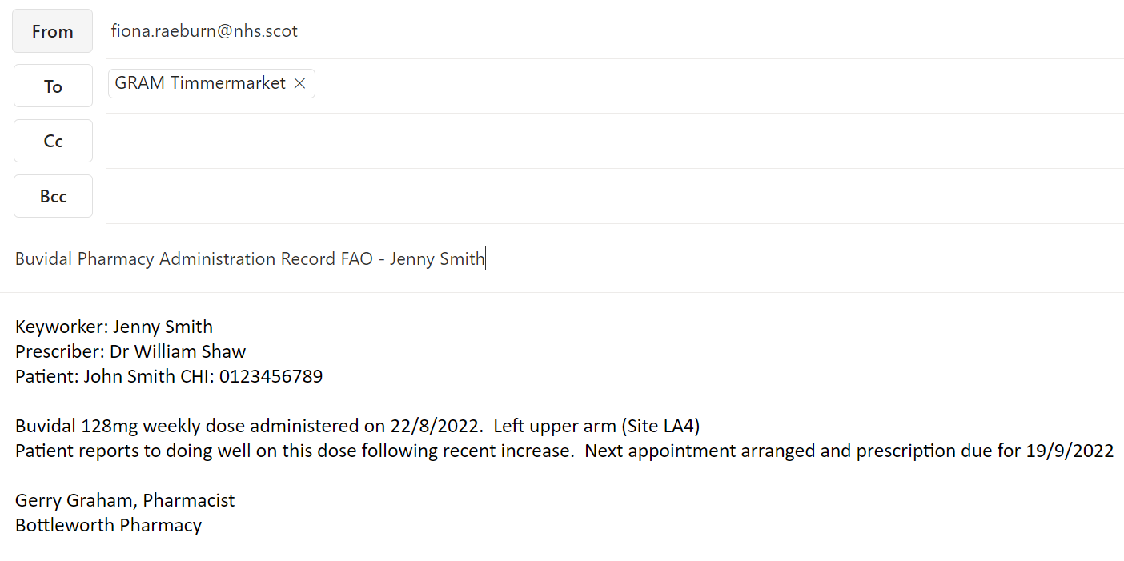

Pharmaceutical particulars

  - List of excipients: (All strengths) Soybean phosphatidylcholine, Glycerol dioleate
- Buvidal® 8mg, 16mg, 24mg, 32mg also includes ethanol anhydrous
- Buvidal 64mg, 96mg, 128mg also includes N-Methylpyrrolidone

  - Incompatibilities: This medicinal product must not be mixed with other medicinal products.

  - Shelf life: 8mg, 16mg, 24mg, 32mg = 30 months. 64mg, 96mg, 128mg = 3 years.

  - Special precautions for storage: Do not refrigerate or freeze.

  - Nature and contents of container: A 1 mL pre-filled syringe (glass, Type I) with plunger stopper (fluoropolymercoated bromobutyl rubber) with needle (½-inch, 23 gauge, 12 mm) and needle shield (styrene butadiene rubber). The pre-filled syringe is assembled in a safety device for post-injection needlestick prevention. The needle shield of the safety syringe may contain rubber latex that may cause allergic reactions in latex-sensitive individuals.
Pack sizes: Pack contains 1 pre-filled syringe with stopper, needle, needle shield, safety device and 1 plunger rod.

Special precautions for disposal and other handling
Important information
- Administration should be made into the subcutaneous tissue
- Intravascular, intramuscular and intradermal administration must be avoided.
- Must not be used if the safety syringe is broken or the packaging is damaged.
- The needle shield of the syringe may contain rubber latex that may cause allergic reactions in latex sensitive individuals.
- Handle the safety syringe carefully to avoid a needle stick. The safety syringe includes a needle protection safety device that will activate at the end of the injection. Do not uncap the safety syringe until you are ready to inject. Once uncapped, never try to recap the needle.
- Dispose of the used safety syringe right away after use. Do not re-use the safety syringe. Before administration Safety syringe parts:
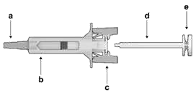
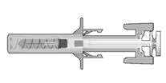
Figure 1

Safety Syringe: Before Use Safety Syringe: After Use

Figure 1: a) Needle shield, b) Syringe Guard Body, c) Syringe (With needle activated) protection mechanism Guard Wings, d) Plunger, e) Plunger Head
Please note that the smallest injection volume is barely visible in the viewing window as the spring of the safety device is “covering” part of the glass cylinder close to the needle.

Administration

Figure 2: Take the syringe out of the cardboard box: pick up the syringe by the syringe guard body. While holding the syringe by the needle shield, insert the plunger rod into the plunger stopper by gently rotating the plunger rod clockwise until secured (see Figure 2).
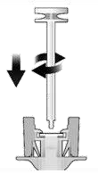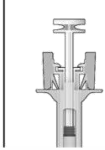
Figure 2

Before After
Inspect the safety syringe closely:
  - Do not use the safety syringe after the expiration date shown on the cardboard box or on the syringe label.
  - A small air bubble may be seen, which is normal.
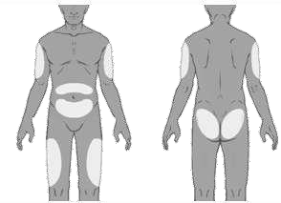
  - The liquid should be clear. Do not use the safety syringe if the liquid contains visible particles or is cloudy.

Figure 3: Choose the injection site. Injections should be rotated between sites in the buttock, thigh, abdomen, or upper arm (see Figure 3) with a minimum of 8 weeks before re-injecting a previously used injection site. Injections on the waistline or within 5 cm of the navel should be avoided.

Figure 3

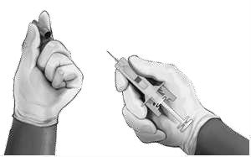

Figure 4

Figure 4: Put on gloves and clean the injection site with a circular motion using an alcohol wipe (not provided in the pack). Do not touch the cleaned area again before injecting.

While holding the safety syringe by the syringe guard body as shown (see Figure 4), carefully pull the needle shield straight off. Immediately dispose of the needle shield (never try to recap the needle). A drop of liquid may be seen at the end of the needle. This is normal.

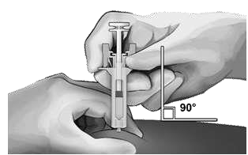
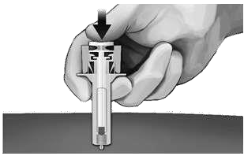
Figure 5

Figure 5: Pinch the skin at the injection site between the thumb and finger as shown (see Figure 5).
Hold the safety syringe as shown and smoothly insert the needle at an angle of approximately 90° (see Figure 5). Push the needle all the way in.

Figure 6: While holding the syringe as shown (see Figure 6), slowly depress the plunger until the plunger head latches between the syringe guard wings and all the solution is injected.
Figure 6

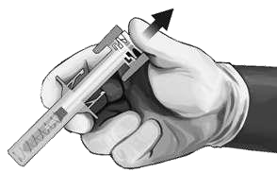
Figure 7

Figure 7: Gently pull the needle out of the skin. It is recommended that the plunger is kept fully depressed while the needle is carefully lifted straight out from the injection site (see Figure 7).

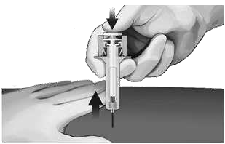

Figure 8: As soon as the needle has been completely removed from the skin, slowly take the thumb off the plunger and allow the syringe guard to automatically cover the exposed needle (see Figure 8). There may be a small amount of blood at the injection site, if required wipe with a cotton ball or gauze.
Figure 8

Disposing of the syringe

Any unused medicinal product or waste material should
be disposed of in accordance with local requirements

