**NHS Grampian**

**Service Level Agreement**

**Injecting Equipment Provision (IEP)**

|  |  |
| --- | --- |
| **SLA Reference** | SLA_Injecting Equipment Provision |
| **Version** | 4 |
| **Review date** | March 2026 |
| **Author** | Peter Maclean |
| **Approved By** | David Pfleger |

|  |  |  |
| --- | --- | --- |
| **Revision Chronology** | | |
| **Version Number** | **Effective Date** | **Reason for Change** |
| 1 | April 2021 | Annual Update |
| 2 | April 2023 | Fees Update |
| 3 | April 2024 | Annual Update |
| 4 | April 2025 | Annual Update |

|  |  |
| --- | --- |
| **Summary of Changes from Previous Version** | General minor changes to wording and grammatical alterations.  Update to service provider list for North Aberdeenshire. |
| **Supersedes** | **Version 3 – April 2024** |
| **Consultation Undertaken** | **Laura Karim**  Pharmaceutical Care Services Improvement & Development Manager  **Lucy Skea**  Substance Use Pharmacist  **Bethany Potter**  Substance Use Pharmacist |

Contents

1. Introduction 3

2. Background to service 3

3. Service Aims 4

4. Service outline and standard 4

5. Training requirements 7

6. Monitoring & evaluation 7

7. Claims and payment 7

8. References 8

Appendix 1 – Current IEP Providers 9

Appendix 2 – Management of exposure to BBV 11

Appendix 3 – Management of blood spillage 12

# **Introduction**

This Service Level Agreement acts as a contract between NHS Grampian and the pharmacy contractor and commits the contractor to provide the services as defined by, and using documents provided in, this Service Level Agreement. Services will be provided within the legal and ethical framework of pharmacy as a whole and in line with the Scottish Government guidelines for services providing injecting equipment1.

A three month notice period must be provided if either party wishes to terminate this contract. Where a breach in terms of the SLA has occurred the 3 month notice period may not apply.

This agreement is for the period 1st April 2025 – 31st March 2026, however, remains valid and must be adhered to as per the agreement whilst under review.

# **Background to service**

Provision of injecting equipment (previously known as needle exchange) was introduced in Scotland in response to an outbreak of HIV in the 1980s and proved [effective in reducing transmission of this blood borne virus (BBV](https://www.ncbi.nlm.nih.gov/books/NBK469720/)). Although HIV remains an issue in some areas, Hepatitis C Virus (HCV) is now the more prevalent BBV in people who inject drugs. The majority of new diagnoses of HCV present in this group.

People who inject drugs are also prone to a number of wider health risks including but not limited to; [overdose, bacterial infection, injecting site injuries and deep vein thrombosis.](https://www.nrscotland.gov.uk/publications/drug-related-deaths-in-scotland-in-2023/)  General health is also impacted with people developing chronic diseases on average some 15 years ahead of the general population.

Injecting equipment providers (IEPs) are therefore critical in reducing both injecting and other related harms.

Community pharmacies are well placed to support people who inject drugs due to:

* location at the heart of local communities
* the wide range of general health services available
* ability to provide “drop in” access to a health care professional
* existing relationships with people accessing the pharmacy for other services

# **Service Aims**

The service aims to provide:

* Non-judgemental, trauma informed access to injecting equipment and paraphernalia for people who inject drugs
* Facility for collection and disposal of used equipment. (It is a requirement of all community pharmacies to have facility for disposing sharps. This is not limited to IEP pharmacies.)
* Basic safer injecting and harm reduction advice
* Provide training on signs and symptoms of overdose and naloxone supply.
* Onward signposting and referral as required e.g. for blood borne virus testing, vaccinations (eg Hep B, flu)and to GP, A&E etc.
* A link to specialist drug and alcohol services ([Key Contacts-See SUS](https://www.communitypharmacy.scot.nhs.uk/nhs-grampian/pages/grampian-contacts/))
* Encourage access to and provide wider pharmacy services such as NHS Pharmacy First Scotland, emergency hormonal contraception etc.

# **Service outline and standard**

4.1. An IEP service may only be provided by an NHS Grampian approved provider.

4.2. The IEP service should maintain client confidentiality and privacy at all times

4.3 The service must be made available throughout the pharmacy opening hours, and it should be clearly advertised that the pharmacy operates a “needle exchange” service. The “needle exchange” window sticker should be displayed.



Transactions should be undertaken in a private area

* 1. All needles, syringes, sharps bins and other paraphernalia supplied under the pharmacy IEP scheme must be accessed from the approved supplier and product list as specified by NHS Grampian. This should include water for injection and foil in addition to injecting equipment and sharps bins. Equipment will be provided free of charge to both service provider and client.

**Current NHS Grampian Approved Supplier**

|  |
| --- |
| Orion Medial Supplies LTD  Products - Orion Medical Supplies (See Link for Supply) |

4.5 Clients should be provided with the volume and type of equipment appropriate to the frequency of injection and type of substance(s) used. There is no upper limit on the amount of equipment that may be supplied.

4.6. Pharmacy staff should provide safer injecting and harm reduction advice specific to the patient’s requirements. This includes:

* Using a new set of injecting equipment and paraphernalia for every injection
* Using the smallest needle size appropriate to the injecting site and substance used
* Awareness of the different types of substances used and tailoring harm reduction advice accordingly (e.g. need for vitamin C with opioids but not with steroids)
* Importance of cleaning and rotating the injecting site
* How to use the different items of paraphernalia e.g. addition of vitamin C in small amounts, risks associated with non-sterile water sources
* Reducing risk of overdose. Responding to overdose and administering naloxone
* The need for regular BBV testing and providing, or linking clients in, with testing services (BBV home testing kits available at all community pharmacies)
* Advice on returning equipment and associated danger to self and wider public of not returning, publically disposing equipment.

4.7 Pharmacies providing an IEP service must also deliver Naloxone training and supply to those at risk, or likely to witness an overdose. People accessing IEP services should be proactively offered naloxone. Pharmacies should also adhere to the [national naloxone emergency supply service](https://www.publications.scot.nhs.uk/files/pca2023-p-34.pdf).

4.8 Pharmacies operating an IEP service will be provided with appropriate waste containers free of charge by NHS Grampian (normally a 60 litre special waste bin) to receive all used equipment. NHS Grampian will make arrangements for the uplift and disposal of full containers.

Currently this contract is delivered by Perfect Hygiene. Queries should be directed through their website [www.perfecthygiene.co.uk/nhs.html](http://www.perfecthygiene.co.uk/nhs.html) or by emailing: admin@perfecthygiene.co.uk.

4.9. Clients should be encouraged to return used needles and syringes in the sealed sharps bin supplied. If they return with loose injecting equipment they should either be given an individual sharps bin to dispose of the equipment or, if unavailable, asked to place the equipment directly into the 60 Litre bin. To minimise the risk of needle stick injury this bin should then be sealed and set aside for uplift thereafter. **Pharmacy staff should never handle loose returned injecting equipment.**

4.10. The service provider is responsible for entering all IEP transactions onto the approved IT system (currently neo360®). **Direct entry of data into neo360® at point of exchange is required** to ensure maximal data accuracy. This may be undertaken by use of PC, laptop or tablet at the point of exchange. If you require access to neo360**®** or have any IT queries please contact [gram.pharmaceuticalcareservices@nhs.scot](mailto:gram.pharmaceuticalcareservices@nhs.scot). For additional guidance please see the [NHS Grampian SUS webpage](https://www.communitypharmacy.scot.nhs.uk/nhs-grampian/pages/community-pharmacy-local-services/substance-use-service-sus-addiction-support/).

4.11. Transactions should be recorded using a client identifier that is both anonymous and unique. This should consist of the first initial of the forename and the 1st and 4th initials of the surname followed by the date of birth in the format ABCdd/mm/yyyy.

E.g. John Smith born 1st January 1990 would have the identifier JST01/01/1990.

For patients who have surnames of less than four characters a star should be used for the third letter e.g. John Hay 12/12/95 would have the identifier JH*12/12/1995.

Clients should be encouraged to utilise the same identifier at each attendance in order to provide an accurate estimate of the unique number of clients attending services in Grampian and more widely in Scotland. They should be reassured that this information will not be used to identify them.

4.12. Approved information leaflets on safer injecting, harm reduction and blood borne virus transmission should be made freely available to clients. These are available from NHS Grampian Health Information Resources Service

Website: [www.nhsghpcat.org](http://www.nhsghpcat.org);

Telephone: (01224) 558504;

Email: gram.resources@nhs.scot

4.13 All staff working in the service should be aware that an IEP service is delivered from the premises. Those directly involved in delivery of IEP should be given the opportunity to access Hepatitis B vaccination. This is provided free of charge to pharmacy staff by NHS Grampian occupational health department.

To arrange an appointment(s) call (01224) 553663 or email gram.ohs@nhs.scot.

# **Training requirements**

5.1. All staff members involved in the delivery of this SLA should have undertaken training on the delivery of this service. A recording of training sessions delivered by Scottish Drugs Forum can be [accessed here](https://www.sdftraining.org.uk/online-learning). For those looking for additional information, eLearning modules are available from [Exchange Supplies](https://training.exchangesupplies.org/) and [Scottish Drugs Forum](https://www.sdftraining.org.uk/e-learning). (Click on each service name to access).

5.2. Staff participating in IEP should be encouraged to attend NHSG approved IEP training events. It is the responsibility of the pharmacy to ensure they are up to date with any changes or developments if they cannot attend.

5.4. The service provider must ensure that all staff are aware of the correct procedure and action to be taken in the event of a needle stick injury ([see NHS Grampian Blood Borne Virus Community Exposure Guidance](https://www.communitypharmacy.scot.nhs.uk/nhs-grampian/wp-content/uploads/sites/10/Blood-Borne-Virus-Community-Exposure-1.pdf)). The Summary Flowchart- should be displayed in an area of the pharmacy where staff can easily access the information.

5.5. In the unlikely event of a blood spill within the pharmacy, staff should follow current NHS Grampian Blood Spill guidance (Appendix 2).

# **Monitoring & evaluation**

6.1 It is a requirement of the service that appropriate records are kept and maintained by the pharmacy contractor, to enable verification of service provision and training undertaken by staff. These records may be used for information for internal and external audit and evaluation purposes. For IEP the recording system is currently neo360®.

6.2. NHS Grampian regularly monitors service provision across all providers of IEP. Data is submitted to Public Health Scotland data team on an annual basis for national review and report.

6.3. Participating pharmacies will be required to participate in service evaluation and audit, including but not limited to; use of neo360 at time of transaction, availability of all items at all times (including water for injection and foils). Payments will be withheld if evidence otherwise.

# **7. Claims and payment**

7.1 Neo360® is the current approved IT system for IEP services on which all needle exchange transactions must be recorded at point of exchange. NHSG PCCT generate an invoice for each contractor from neo360® on the 7th of the following month. The service provider (community pharmacy) must ensure that data is accurate prior to this date. To do this:

* Login to neo360 on pharmacy manager account
* Select “reports”
* Select “monthly transactions” in needle exchange section
* Ensure date displayed is 1st of the month you are looking to review
* Tick “client reference code”
* Click on “generate”

7.2 Any errors should be reported to the Pharmaceutical Care Services ([gram.pharmaceutical](mailto:Fiona.raeburn@nhs.scot)careservices@nhs.scot) to amend. There is no requirement for contractors to submit a paper claim.

7.3 Participating pharmacies will receive a monthly retainer fee of £62.85 and will be paid £2.70 per client transaction

7.4 Pharmacies should monitor the reimbursement they have received for the service and raise any concerns within 3 months of when payment should have been received. Any claim queries raised after this time will be deemed as an historical claim and will only be considered by the Pharmacy Performance and Governance Group for payment if information detailing why the issue wasn’t raised earlier is supplied.

# **8. References**

Scottish Government (2010). Guidelines for services providing injecting equipment: Best practice recommendations for commissioners and injecting equipment provision (IEP) services in Scotland. Available from: [www.gov.scot/Publications/2010/03/29165055/0](http://www.gov.scot/Publications/2010/03/29165055/0)

# **Appendix 1 – Current IEP Providers**

**ABERDEEN CITY**

***Alcohol and Drugs Action, 7 Hadden Street, Aberdeen, AB11 6NU. Freephone: 03333 448355***

***Helpline: (01224) 594700***

Bucksburn Pharmacy 9-11 Inverurie Rd, Bucksburn, Aberdeen AB21 9LJ (01224) 714476

Clear Pharmacy 3 Alford Place, Aberdeen, AB10 1YD. (01224) 646325

Dickies Pharmacy 44 Moir Green, Northfield, Aberdeen, AB16 7GS (01224) 697978

Douglas Dickie Chemist 96 Victoria Road, Torry, Aberdeen, AB11 9DU (01224) 878459

Dickies Pharmacy 9 Victoria Street, Dyce, Aberdeen, AB21 7AU (01224) 722275

Ferryhill Pharmacy 9 Millburn Street, Aberdeen, AB11 6SS (01224) 580950

Gardner Drive Pharmacy 68 Gardner Drive, Kincorth, Aberdeen, AB12 5SD (01224) 874608

Holburn Pharmacy 560 Holburn Street, Aberdeen, AB10 7LJ (01224) 581685

John Ross Chemists 109 Hayton Road, Tillydrone, Aberdeen, AB24 2RN (01224) 277434

Lewis Road Pharmacy Lewis Road, South Sheddocksley,

Aberdeen, AB16 6TU (01224) 699424

Rowlands Pharmacy City Hospital, Park Road, Aberdeen, AB24 5AU (01224) 636597

**ABERDEENSHIRE**

**Alcohol and Drugs Action Mobile service covering all areas Call Alex on**

**07743 936124**

**NORTH ABERDEENSHIRE**

Buchanhaven Pharmacy 23 Skelton Street, Peterhead, AB42 1HR (01779) 473525

**NHS Grampian Drug and Alcohol Service, 48 Broad Street, (01346) 585160**

**Fraserburgh, AB43 9AH**

Strachan Pharmacy 69 High Street, Banff, AB45 1AN (01261) 812404

Webster’s Pharmacy 45 High Street, Strichen, AB53 6SQ (Part time) (01771) 637204

Porter Pharmacy Mid Street 49 Mid Street, Fraserburgh, AB43 9AJ (01346) 513298

**CENTRAL ABERDEENSHIRE**

Duke Street Pharmacy 26 Duke Street, Huntly, AB54 8DL (01466) 792141

Strachan Pharmacy 29 Main Street, Turriff, AB53 4AB (01888) 562403

Will Chemists 35 West High Street, Inverurie, AB51 9QQ (01467) 620475

**SOUTH ABERDEENSHIRE**

Charles Michie Chemist 24 Market Square, Stonehaven, AB39 2BE (01569) 762298

Davidsons Chemists 61 High Street, Banchory, AB31 5TJ (01330) 822542

**MORAY**

***Arrows (a Quarriers’ service) 23 High Street, Elgin, IV30 1EE (01343) 543792***

Baird’s Pharmacy 175-177 High Street, Elgin, IV30 1DW (01343) 542571

Bishopmill Pharmacy 20 North Street, Bishopmill, Elgin, IV30 4EF (01343) 547374

Clark’s Pharmacy 12-18 Regent Street, Keith, AB55 5DU (01542 882553

Right Medicine Pharmacy 1 High Street, Buckie, AB56 1AL (01542) 831116

Right Medicine Pharmacy 23a Clifton Road, Lossiemouth, IV31 6DJ (01343) 812818

Your local Boots Pharmacy 88/94 High Street, Forres, IV36 1NX (01309) 673370

Your local Boots Pharmacy Glassgreen Centre, 2 Thornhill Road, Elgin, (01343) 542186

IV30 6GQ

# **Appendix 2 – Management of exposure to BBV**

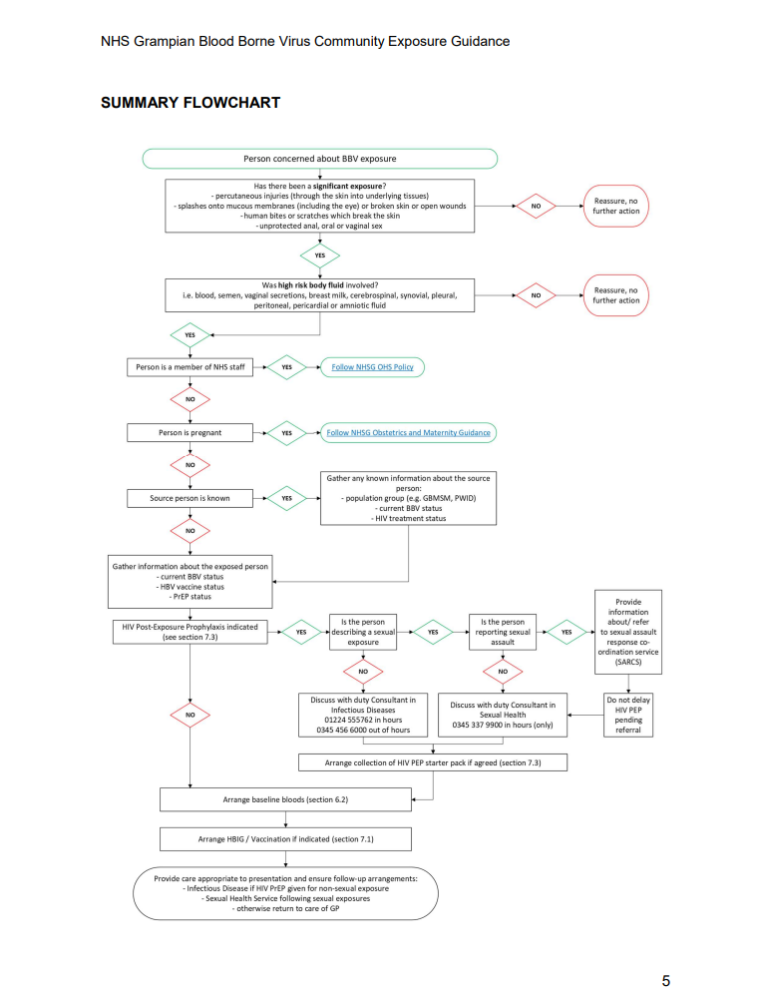

# **Appendix 3 – Management of blood spillage**