**NHS GRAMPIAN**

**SERVICE LEVEL AGREEMENT**

**Take Home Naloxone – Training and Supply**

|  |  |
| --- | --- |
| **SLA Reference** | SLA ”Take home” Naloxone - Training and Supply |
| **Version** | 5 |
| **Review date** | March 2026 |
| **Author** | Peter Maclean  Service Manager- Primary Care Contracts |
| **Approved By** | David Pfleger  Director of Pharmacy |

|  |  |  |
| --- | --- | --- |
| **Revision Chronology** | | |
| **Version Number** | **Effective Date** | **Reason for Change** |
| 1 | April 2020 | New SLA |
| 2 | April 2021 | Annual Update |
| 3 | April 2023 | Annual Update |
| 4 | April 2024 | Annual Update |
| 5 | April 2025 | Annual Update |

|  |  |
| --- | --- |
| **Summary of Changes from Previous Version** | General minor changes to wording and grammatical alterations.  Change of SLA name from “Naloxone Training and Supply” to “Take Home Naloxone- Training and Supply”    Addition of Appendix 1 – Training Checklist  Addition of Appendix 2 - Naloxone Key Information Sheet |
| **Supersedes** | Version 4 – April 2024 |
| **Consultation Undertaken** | **Laura Karim**  Pharmaceutical Care Services Improvement & Development Manager  **Lucy Skea**  Lead Specialist Pharmacists in Substance & Medicines Use  **Bethany Potter**  Specialist Pharmacist Aberdeen City Drug and Alcohol Service |

Contents

1 Introduction 3

2 Background to service 3

3 Service aims 3

4 Service outline and standard 4

5 Training requirement 5

6 Monitoring & evaluation 5

7 Claims and payment 6

8 References 6

# Introduction

This Service Level Agreement (SLA) acts as a contract between NHS Grampian and the pharmacy contractor and commits the contractor to provide the services as defined by the current supporting documentation which must be read in conjunction with this SLA.

Take home Naloxone supply is mandatory for those pharmacies signed up to deliver Level 1 Substance Misuse Service from Community Pharmacy.

Staff should have completed the approved naloxone training (section 5) prior to signing up to this SLA. Services will be provided within the legal and ethical framework of pharmacy as a whole.

A three months’ notice period must be provided if either party wishes to terminate this contract. Where a breach in terms of the SLA has occurred the 3 month notice period may not apply.

Please note the CPS “holding a supply in the pharmacy and emergency supply” of Naloxone is covered by community pharmacy Public Health Service as part of National service for all pharmacies.

This agreement is for the period 1st April 2025 – 31st March 2026, however, remains valid and must be adhered to as per the agreement whilst under review.

# Background to service

In 2023, [1172 people in Scotland lost their lives](https://www.nrscotland.gov.uk/publications/drug-related-deaths-in-scotland-in-2023/) as a result of a drug related death. This has more than doubled since 2014. 83 of these deaths were in Grampian, 60 of whom had opioids in their system which means that, if naloxone had been available,60 of these lives could have been saved.

* Naloxone is a medication which can temporarily reverse the effects of opioid drugs. Accidental overdose is a common cause of death among people who use heroin, morphine and similar drugs. These drugs are also referred to as opioids.

[The Scottish Naloxone Take Home Programme](https://publichealthscotland.scot/publications/national-naloxone-programme-scotland-annual/national-naloxone-programme-scotland-monitoring-report-202122-and-202223/) (NNP) aims to prevent fatal overdoses by training the following groups on how to identify and respond to overdose and administer naloxone:

* people at risk of opioid overdose
* people in contact with those at risk (e.g. family members)
* services in contact with those at risk of opioid overdose

The overall aim of [Scotland’s National Naloxone Programme](https://publichealthscotland.scot/publications/national-naloxone-programme-scotland-annual/national-naloxone-programme-scotland-monitoring-report-202122-and-202223/) is to prevent fatal opioid overdoses. Administration of naloxone provides time for emergency services to arrive and for further treatment to be given. Following suitable training, THN kits are issued to people at risk of opioid overdose, their friends and family and service workers in order to help prevent overdose deaths.

Opioid overdose may be a risk for people prescribed opioid medications for any indication including pain or opioid dependence and/or addiction. Professionals should make naloxone available to those at risk of accidental overdose regardless of the indication of the opioid prescribed

Naloxone supply for people that use drugs is part of NHS Grampian and Alcohol and Drug Partnerships’ goals to reduce harm and promote recovery. Community Pharmacies participation in Naloxone Supply to reduce fatal opioid overdose is a key part of this.

# Service aims

The aims of the service are:

* To provide overdose awareness and naloxone training and supply to people at risk of, or who are likely to witness, opioid overdose
* To make naloxone as widely and easily available as possible.

For this reason all community pharmacies who deliver level 1 SMS must sign up to this SLA. It is strongly recommended that all community pharmacies, including those who do not deliver level 1 SMS, sign up to this SLA.

* To supply naloxone in line with https://www.nhsgrampian.org/globalassets/services/medicines-management/policies/guide_naloxones.pdf
* NB: either Prenoxad® intramuscular injection or naloxone nasal spray (naloxone 1.26mg or Nyxoid® nasal spray) may be supplied.

# Service outline and standard

* 1. Pharmacy contractors must ensure that pharmacy staff are able to deliver this service throughout opening hours:
* Offer the service to all eligible people attending the pharmacy.
* Where supply is requested, make this **supply at the time of request** wherever possible.
  1. Check the status of any existing supplies e.g. is the naloxone still in date, opened, needles used etc. and resupply where necessary.
  2. Use the “Take Home Naloxone Key Points Sheet”(appendix 2) or the manufacturers product risk materials e.g [Nyxoid 1.8 mg nasal spray, solution in a single-dose container - Risk Management Materials - (emc) (medicines.org.uk)](https://www.medicines.org.uk/emc/product/9292/rmms#gref), to ensure those who are supplied with naloxone have a basic understanding of:
* the risks, signs and symptoms of drug overdose
* how naloxone works and how to use each of the naloxone products (Videos can be accessed here [www.prenoxadinjection.com/video/admin.mp4](http://www.prenoxadinjection.com/video/admin.mp4), [www.nyxoid.com/uk](http://www.nyxoid.com/uk) and <https://naloxone.uk/> )
* basic life support and the recovery position
* the importance of calling an ambulance
  1. Provide advice and support to anyone who returns having used the training and/or naloxone supply.
  2. Make a new or replacement supply of naloxone as appropriate. **You should add a pharmacy address label to the product and annotate the date this item was issued.**
  3. Display a suitable poster to advertise the fact you can supply naloxone and maintain a supply of Prenoxad® , Naloxone 1.26mg nasal and Nyxoid® information leaflets. Available with the links above and from https://naloxone.uk/wp-content/uploads/sites/7/2023/03/UK-03385-Naloxone-patient-and-carer-guide-RGB.pdf [www.nhsghpcat.org](http://www.nhsghpcat.org); Email: [gram.resources@nhs.scot](mailto:gram.resources@nhs.scot); Telephone: 01224 558504
  4. Naloxone supplies can either be directly entered into the approved data collection system (currently NEO360) or by completing the Grampian "Record of Naloxone Training. Supply and Resupply" (appendix 11) and subsequently entered into NEO 360.

# Training requirement

* 1. Any member of the pharmacy team can be trained to deliver this service it does not have to be a pharmacist The service works better where it is not solely reliant on the pharmacist and where multiple members of the pharmacy team are trained.
  2. It is the contractor’s responsibility to ensure all staff delivering the service have completed appropriate training, are competent and have the required personal and technical skills to provide this service at all times the pharmacy is open.
  3. Following TURAS courses are available:

[Pharmacy Naloxone Service - Lesson 1 - Drug Related Deaths in Scotland | Turas | Learn (nhs.scot)](https://learn.nes.nhs.scot/70847/pharmacy-cpd-resources/pharmacy-services-essential-learning/community-pharmacy/community-pharmacy-emergency-naloxone-holding-service/pharmacy-naloxone-service-lesson-1-drug-related-deaths-in-scotland) (all three sections to be completed)

Pharmacy Naloxone Service- Lesson 2- Identifying an overdose

Pharmacy Naloxone Service-Lesson 3- Naloxone and its administration

# Read and Understand - [Guidance for Drug Treatment Services in Grampian Undertaking Supply of Naloxone to People at Risk of Opioid Overdose, Significant Others And Services In Contact With Those At Risk (nhsgrampian.org)](https://www.nhsgrampian.org/globalassets/services/medicines-management/policies/guide_naloxones.pdf)

* 1. A suitable area in the pharmacy should be identified to ensure privacy and confidentiality is maintained whilst delivering the service.
  2. Following training gram.pharmaceuticalcareservices@nhs.scot should be contacted to set new naloxone pharmacies up on the electronic database (neo360®) or add staff names from existing naloxone pharmacies to the system.

# Monitoring & evaluation

* 1. It is a requirement of the service that appropriate records are kept and maintained by the pharmacy contractor, to enable verification of service provision and training undertaken by staff members.
  2. The Record of Training and Supply should be stored securely and confidentially (where information is not entered directly into neo360® at point of transaction). Data entered into NEO 360 will be used for payment verification purposes.
  3. Data is monitored both locally by NHS Grampian and the Alcohol and Drug Partnerships and nationally by Information Services Division through analysis of neo360® data. ([See CP Grampian website](https://www.communitypharmacy.scot.nhs.uk/nhs-grampian/pages/community-pharmacy-local-services/substance-use-service-sus-addiction-support/) for additional neo360 guidance)
* Details of training/supply will be recorded and held confidentially on the NHS Grampian electronic database (neo 360).
* Data will be shared anonymously with the NHS for purpose of reporting and research.

When consent is gained the “Data Sharing Consent” tick-box at the bottom of the patient details tab on neo must be ticked as follows.

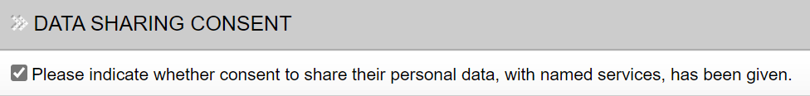

* 1. Pharmacies may be required to participate in service evaluation and audit.

# Claims and payment

* 1. Supplies made to individuals who use the Level 1 SMS provision in community pharmacy are reimbursed for this service through their monthly patient fee for SMS patients.
  2. The payment for supplies made to individuals who do not use the level 1 SMS provision in community pharmacy can be claimed using the PCCT claim workbook by 7th of the following month for payment. Payment is awarded at £15 per training and supply of naloxone made. For all Wholesaler invoices should be submitted for the reimbursement of Naloxone stock costs.
  3. Payments will be subject to periodic verification by PCCT and PCS team.

# References

“Guidance for Services In Grampian to Supply Naloxone to People at Risk of Opioid Overdose, Significant Others and Services in Contact with those at Risk“ Available from: <https://www.nhsgrampian.org/globalassets/services/medicines-management/policies/guide_naloxones.pdf>

Grampian naloxone resources: [www.hi-netgrampian.scot.nhs.uk/naloxone/](http://www.hi-netgrampian.scot.nhs.uk/naloxone/)

[National naloxone programme Scotland - monitoring report 2021/22 and 2022/23 - National naloxone programme Scotland: annual - Publications - Public Health Scotland](https://publichealthscotland.scot/publications/national-naloxone-programme-scotland-annual/national-naloxone-programme-scotland-monitoring-report-202122-and-202223/)

[National Naloxone Programme - Search the datasets - National Datasets - National Data Catalogue - Health intelligence and data management - Resources and tools - Public Health Scotland](https://publichealthscotland.scot/resources-and-tools/health-intelligence-and-data-management/national-data-catalogue/national-datasets/search-the-datasets/national-naloxone-programme/)

Opioids: risk of dependence and addiction - GOV.UK ([www.gov.uk](http://www.gov.uk))

**Appendix 1**

**Naloxone Take Home Program Grampian - Record of Training and Supply**

**TRAINING (ONE TO ONE CHECKLIST COVERED WITH PERSON)**

Name of Service:

Staff Member Name:…...…………………….………………………………….……………………….

Person at risk  Family Member/Friend  Service Worker

M  F Trainee Name: ……………………………………………….……………….………..

CHI/Date of Birth: ………………….………… Unit Number (SMS only)…………………………..

Address: ………………………………………………………………..…….…………….……………

……………………………………………………………………… Postcode: …….…………………

Prison Release date (prison only): …………………………..

Training checklist completed  Training Declined  Reason…………………………..…

**Naloxone supply**

Kit 1: Prenoxad  Nyxoid  Naloxone Nasal Spray 1.26mg

Batch no.: …..………….……….. Expiry Date: ……….……

Spare: Prenoxad  Nyxoid  Naloxone Nasal Spray 1.26mg

Batch no.: …..………….……….. Expiry Date: ……….……

1st supply  Spare supply  Used on self  Used on other

(Complete reverse) (Complete reverse)

Expired  Confiscated  Damaged  Lost  Not known

Or declined supply of naloxone  State Reason ………………………………………………

I consent to: -Details of this training/supply being recorded on the electronic database

-Anonymous sharing of data with the NHS for purpose of reporting and research

Signed (trainee): …………………………………………………….

Signed (staff): ……………………………………………………. Date: ……………………….

**NALOXONE RESUPPLY – Where the naloxone kit has been used on somebody**

When did the overdose occur? (Approximate date):………..………..…………………………....

Who administered the naloxone?

Self  Paramedic  Another person  Unknown

Where did the overdose occur?

My own home  Somebody else’s home  Another indoor location

Outdoors  Other (state)……………………………………………………………

What was the outcome?

Opioid reversed, person went to hospital

Opioid reversed, person did **not** go to hospital

Person did not survive

Kit not used

Not known

Additional Information:

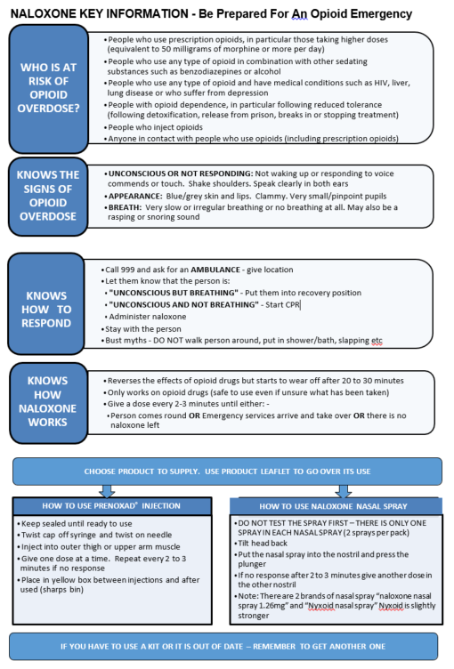**Appendix 2**