|  |  |
| --- | --- |
| **NHS Grampian**  **Service Level Agreement**  **Waste Disposal and Collection Service** | |
| **SLA Reference** | SLA_Waste Disposal and Collection Service |
| **Version** | 8 |
| **Review date** | March 2026 |
| **SLA status** | Mandatory |
| **Author** | Peter Maclean |
| **Approved By** | David Pfleger |

|  |  |  |
| --- | --- | --- |
| **Revision Chronology** | | |
| **Version Number** | **Effective Date** | **Reason for Change** |
| 1 | 2018 | New SLA |
| 2 | 2019 | Annual Update |
| 3 | 2020 | Annual Update |
| 4 | Sept 2020 | Update Sharps Waste and Audit |
| 5 | 2021 | Annual Update |
| 6 | April 2023 | Annual Update |
| 7 | April 2024 | Annual Update |
| 8 | April 2025 | Annual Update |

|  |  |
| --- | --- |
| **Summary of Changes from Previous Version** | No changes from previous version |
| **Supersedes** | Version 7 – April 2025 |
| **Consultation Undertaken** | **Laura Karim**  Pharmaceutical Care Services Improvement & Development Manager  **Neil Duncan**  Waste Management Officer |

**Contents**

1. Introduction 3

2. Background to service 3

3. Service aims 3

4. Service outline and standard 3

5. Training requirement 5

6. Monitoring & evaluation 6

7. Claims and payment 6

8. References 6

Appendix 1 7

Appendix 2 8

# Introduction

This Service Level Agreement (SLA) acts as a contract between NHS Grampian and the contractor and commits the contractor to provide the services as defined by a Prescribed Medicines and Sharps Waste Disposal Service to patients in Grampian for the period to include 2023/24 financial year.

Pharmacy contractors must be registered for a paragraph 39 exemption to the Waste Management Licensing (Scotland) Regulations 2011 (as amended) – this process is free of charge and involves a simple online registration process.

Pharmacy contractors have a Duty of Care for waste as laid out by the Scottish Environment Protection Agency. <https://www.sepa.org.uk/regulations/waste/activities-exempt-from-waste-management-licensing/>

This agreement is for the period 1st April 2025 – 31st March 2026, however, remains valid and must be adhered to as per the agreement whilst under review.

# Background to service

Pharmacy contractors are required to accept medicine and sharps waste in appropriate bins from patients being treated at or in a homely setting for uplift and disposal by NHS Grampian.

# Service aims

To provide patients with a robust route for safe disposal of prescribed medicines and sharps.

To establish a safe and robust community pharmacy disposal service for patients in NHS Grampian.

To ensure pharmacy staff understand and implement safe handling and storage of waste in their premises.

To ensure that healthcare professionals and patients in NHS Grampian requiring such a service are aware of and know how to access it.

To work within the health & safety requirements and infection control guidance for handling segregating and storing used medicines and sharps bins.

# Service outline and standard

* 1. Change to the way that healthcare waste is disposed of has been introduced across the whole of NHS Scotland, and the following is a summary of the changes that require to be implemented within community pharmacies;
* Non-hazardous medicinal wastes - these require to be disposed of in a 22 litre blue bodied bin with a blue lid (This will include surplus medicines, patient returns, bottles, containers, tablet strips etc. that may be contaminated with medicinal wastes.);
* Non-hazardous medicinal sharps (needles, vials, broken glass etc.) – must be disposed of in a 5 Litre yellow bin with blue lid;
* Hazardous medicinal waste (Cytotoxic or Cytostatic) – must be disposed of in a 22 Litre blue bodied bin with purple lid (This will include all medicines used in anti-viral, hormonal, antibacterial and immunosuppressant treatments.) See Appendix 2;
* Hazardous medicinal sharps – must be disposed of in 2.5 Litre yellow bodied bin with purple lid;
* Needle exchange sharps bins from patients (diabetic, substance abuse etc.) - can be placed together in 60 Litre yellow bins;
* Methadone cups and bottles (should never be rinsed out) - should be placed within a 60 Litre yellow bin.

Medicinal wastes should NOT be disposed of in 60 Litre yellow bins as they do not meet Transport Regulations. The 22 Litre bins are the largest bins that should be used for disposal of these.

It is mandatory that the labels on all bins are completed fully by staff within the pharmacy premises prior to uplift.

All community pharmacies will be audited for compliance with segregation requirements at some point over the next 12 months. This is a requirement of the new healthcare waste contract that all boards in NHS Scotland must adhere to.

Contractors will be required to:

* Complete registration for a paragraph 39 exemption to the Waste Management Licensing (Scotland) Regulations 2011 (as amended) through SEPA. Evidence of this may be asked for at any time. <https://www.sepa.org.uk/regulations/waste/activities-exempt-from-waste-management-licensing/>
* Ensure an adequate stock of appropriate sizes and colour of bins and lids by liaising with the waste collection contractor and ensuring stocks are pre-ordered.
* Ensure all clinical waste from patients is accepted when presented and disposed of safely and appropriately.
* Ensure safe and appropriate storage and segregation of empty and full prescribed medicines and sharps bins.
* Maintain knowledge relevant to providing the service to patients and undertake further training if required.
* Ensure appropriate Standard Operating Procedures are in place to ensure all pharmacy staff understand their duty of care responsibilities and work within the health & safety requirements and infection control guidance for handling, segregating and storing medicines, and sharps bins.
* Participate in any audit co-ordinated by NHS Grampian.
* Notify NHS Grampian Community Pharmacy Contracts team ([gram.pcctpharmacy@nhs.scot](mailto:gram.pcctpharmacy@nhs.scot)) of any changes in contracted opening hours, regular pharmacist or any other relevant changes that may impact on the collection and delivery of waste materials.
  1. Additional Information

In the unlikely event that a patient returns any black Injecting Equipment Provision (Needle Exchange) sharps containers, these should be accepted and disposed of in the same manner as other prescribed sharps even if the pharmacy does not participate in the Needle and Syringe exchange service.

* 1. Responsibilities of NHS Grampian Waste Management Services:
* To provide a schedule of routine uplifts for prescribed medicines and sharps waste.
* To uplift returned prescribed medicines and sharps presented in sealed and signed approved containers.
* To supply the community pharmacy with sufficient replacement approved containers for pharmacy and patient use.

# Training requirement

* 1. All staff members involved in the delivery of pharmaceutical services should have undertaken core SLA module training.
  2. Staff involved in the delivery of this service should attend and participate in any waste management training provided by NHS Grampian.
  3. NHS Grampian will provide guidance in waste and sharps management for community pharmacists and their support staff to support them in undertaking their duty of care. It is the responsibility of the contractor to ensure that staff involved in the delivery of the service have read and understood the guidance.
  4. Contractors should ensure that all staff involved in the delivery of this service are aware of the procedure on managing a needle stick injury detailed in Appendix 1.
  5. A named member of staff for each contractor will take overall responsibility for ensuring the service is provided to the required standard and for ensuring all staff in the pharmacy have knowledge of and are trained in the operation of the service.
  6. Pharmacy staff and collection point staff are aware of Make Every Opportunity Count (MEOC), and should be confident in raising and discussing health topics with patients. [www.hphsgrampian.scot.nhs.uk/](http://www.hphsgrampian.scot.nhs.uk/)

# Monitoring & evaluation

* 1. Contractors must provide evidence of their registration for a paragraph 39 exemption to the Waste Management Licensing (Scotland) Regulations 2011 (as amended) when requested to do so.
  2. Standard Operating Procedures should be available for all staff to access and should be reviewed every two years or sooner if there are any changes to practice.
  3. Pharmacists, Pharmacy Technicians, and support staff involved in the provision of the service should undertake and retain evidence of relevant CPD/ training.
  4. Provision of the service will be monitored and audited regularly by NHS Grampian. All community pharmacies will be audited for compliance with segregation requirements at some point over the next 12 months. This is a requirement of the new healthcare waste contract that all boards in NHS Scotland must adhere to.

# Claims and payment

* 1. Provision of all appropriate bins and disposal of all waste is undertaken and paid for by NHS Grampian.
  2. An annual payment of £210 will be paid each year in May to contractors providing a signed contract agreement (Annual sign up letter).
  3. This provision will be reviewed each year.

# References

Medicines, Ethics and Practice Guide (current edition). Royal Pharmaceutical Society of Great Britain, London.

Health Facilities Scotland: <http://www.hfs.scot.nhs.uk/publications-/>

Safe Management of Healthcare Waste.

Scottish Health Technical Note 3 Part B – NHS Scotland Waste Management Guidance: Waste Management Policy Template.

Scottish Environment Protection Agency: [www.sepa.org.uk](http://www.sepa.org.uk/)

Information on the NHS Grampian Prescribed Medicines and Sharps Disposal Service available at the Grampian pages of: [www.communitypharmacy.scot.nhs.uk](http://www.communitypharmacy.scot.nhs.uk/)

**Contact Details**

NHSG Waste Management Officer at [neil.duncan3@nhs.scot](mailto:neil.duncan3@nhs.scot)

For issues with waste collections: [NHSScotland-customerservices@tradebe.com](mailto:NHSScotland-customerservices@tradebe.com)

To order stocks of bins and bags: <https://www.perfecthygiene.co.uk/nhs.html>

Or email [admin@perfecthygiene.co.uk](mailto:admin@perfecthygiene.co.uk)

Appendix 1 – Management of Occupational Exposure to Blood Borne Viruses

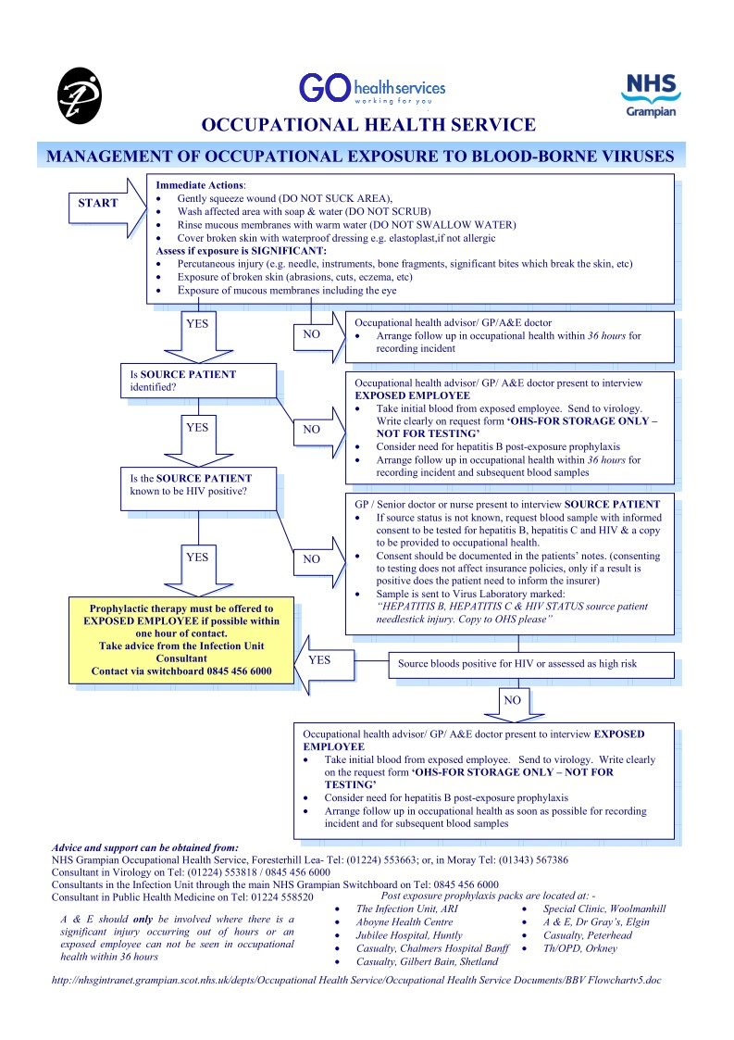

Appendix 2 – Cytostatic Medication List

The medicines listed below must all be disposed of in purple waste streams.

|  |  |
| --- | --- |
| Drug Class | Cytostatic Agents |
| Antibacterials | Chloramphenicol |
| Antivirals | **Medicines active against HIV**  e.g. zidovudine, tenofovir, emtricitabine  **Medicines active against herpesviruses**  e.g. ganciclovir  **Medicines active against viral hepatitis**  e.g. tenofovir, entecavir  **Medicines active against respiratory syncytial virus**  e.g. ribavirin |
| Hormones and other endocrine agents | **HRT products**  **Oral contraceptives**  **Oestrogens**  e.g.diethylstilbestrol  **Progestogens**  e.g. megestrol  **Male sex hormones and antagonists**  e.g. testosterone, finasteride, cyproterone  **Drugs affecting gonadotrophins**  e.g. danazol, triptorelin  **Hypothalamic and pituitary hormones and antagonists**  e.g. gonadotrophin, clomifene  **Prostaglandins and oxytocics**  e.g. dinoprostone, mifepristone, misoprostol, oxytocin, ergometrine  **Hormone antagonists**  e.g. anastrozole, letrozole, tamoxifen, exemestane |
| Immunosuppressants and immunomodulators | **Antiproliferative immunosuppressants**  e.g. azathioprine, mercaptopurine, mycophenolate  Colchicine  Leflunomide  Infliximab  Rituximab  **Other immunosuppressants**  e.g. ciclosporin, tacrolimus  **Other immunomodulating drugs**  e.g. fingolimod, interferons, thalidomide, BCG vaccine |
| Dermatological preparations | Coal tar  Dithranol |