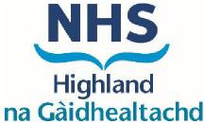

THIS PHARMACY IS CURRENTLY CLOSED
YOUR NEAREST OPEN PHARMACY IS:
THEY ARE OPEN BETWEEN
THIS PHARMACY IS PLANNED TO RE-OPEN

DATE : | TIME :
Tel number for urgent enquiries :

