NHS Highland  Assynt House  Beechwood Park  Inverness  IV2 3BW  Tel: 01463 – 706886 | COMMUNITY PHARMACY SERVICES | 
3rd December 2025

NHS Highland Community Pharmacy Vaccination Services
Support Sheet

Dear Colleague,
Please see the following guidance notes relating to vaccination services to aid you and your teams.
Child Health
Vaccinations to patients who are school age or recent school leaves:
Prior to the administration of vaccines for patients who are in secondary school (including recent school leavers) you may wish to contact the school team within the Child Health Department to confirm the patient’s vaccination history. A record of vaccinations given during secondary school is held by the Child Health School team and these vaccinations are routinely shared with GP practices although these are not always updated onto the GP-IT systems. Please note that those vaccines given during secondary school include HPV, Diphtheria / Tetanus/ Polio (DTP) and MenACWY.
To assist you with your patient assessment when a quick response is required, please contact the Child Health School team on: 01463 701314
Alternatively, the Child Health School team can be contacted by email at: chsp.school@nhs.scot (please note the response via email may take longer than by telephone).
Data Quality
Housekeeping for incomplete VMT records:
The Data Quality team within NHS Highland flag incomplete Vaccination Management Tool (VMT) records on a monthly basis. Any record held on the VMT which is incomplete should be reviewed periodically by community pharmacy teams with the record being either completed where a vaccine has been administered or deleted if not administered. Please see attached VMT guidance for incomplete records.
Duplicate VMT entries
The Data Quality team have reported several duplicate VMT vaccine entries for the same patient recently. Please ensure only one record is created for each individual patient.
Using the NES TURAS Vaccination Management Tool – Making Amendments
When recording a vaccination in TURAS VMT there are two options:
- Enter vaccination Live: (Register Patient, Screen Patient & Vaccinate Patient) - **preferred option**
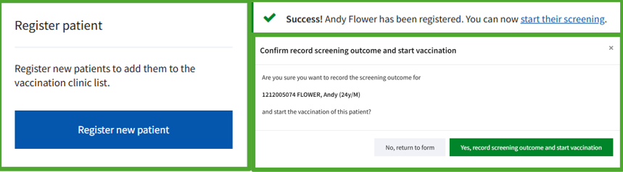

- Record retrospective vaccination event after the vaccination
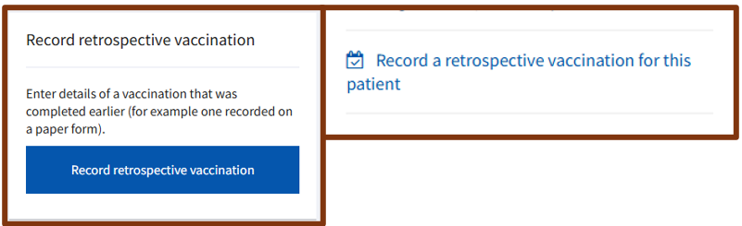
Depending on how the event has been entered, determines how any errors can be amended:
- Entered Live (at the point of vaccination) event amendments:
  - Within an Hour - Vaccinator
  - After 1 hour - Record Manager (nhsh.vaxdq@nhs.scot)

- Retrospective event amendments:
  - Event needs to be re-recorded by Vaccinator and the original deleted by Vaccination DQ (nhsh.vaxdq@nhs.scot)

Entering the event "live" promotes the best outcome for record management.
Not recording the event at the point of vaccination could result in deficient information being available to other vaccination services.
Kind regards

Gayle MacDonald
Vaccination and Immunisation Pharmacist, NHS Highland

