NHS Highland  Assynt House  Beechwood Park  Inverness  IV2 3BW  Tel: 01463 – 706886 | COMMUNITY PHARMACY SERVICES | 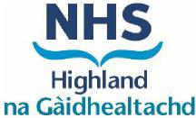

12th September 2025

Gluten Free Food Service Training Refresher

Dear Colleagues,

In alignment with the Pharmaceutical Strategy 2025–2030, NHS Highland remains committed to supporting the continued professional development of our workforce.
We are pleased to share the link below for the Gluten Free Food Service Training Refresher, which forms part of our upskilling initiative.

https://learn.nes.nhs.scot/63144/pharmacy-cpd-resources/pharmacy-services-essential-learning/community-pharmacy/gluten-free-food-service

This resource has been designed to help community pharmacists gain a general understanding of conditions requiring a gluten-free diet and provide them with the necessary information they need to deliver the service.

Many thanks

Community Pharmacy

