NHS Highland  Assynt House  Beechwood Park  Inverness  IV2 3BW  Tel: 01463 – 706886 | COMMUNITY PHARMACY SERVICES | 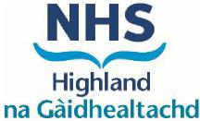

25th August, 2025

Celebrating Success in Community Pharmacy Teams

Dear Colleagues,

Following the NHS Highland Pharmacy Services Strategy Plan, the Community Pharmacy Services office will be introducing a new section on the Community Pharmacy NHS Highland website dedicated to celebrating the achievements of our colleagues.

We are keen to recognise the professional development across all our community pharmacy teams and highlight your successes.

If you have colleagues who have recently completed qualifications—such as NVQ Level 2, Pharmacy Technician registration, or Independent Prescriber status—we would love to hear about it.

Please consider sharing a photo of your colleague holding their certificate or a brief summary highlighting someone you feel deserves special recognition.

Kind regards

Community Pharmacy Services

