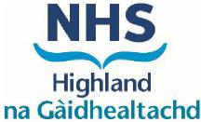
Guide Prices for Commonly Requested Unlicensed Medicines

Effective from 1st April 2025, any patient presenting with a prescription for the items below, please use the prices and information below to procure and endorse unlicensed specials or imports. If you can obtain at this price or lower, you do not need to seek authorisation.

The prices on the pre-approved guide price list are to provide a maximum cost where the Board are happy to approve without prior authorisation; these do not and should not replace the invoice price submitted for payment. Pharmacy teams must ensure that the item is correctly endorsed electronically (and on paper) as per invoice price and not as listed below.

NB Updated circular in respect to Special preparations issued April 2023 - where a product is listed in Part 7S for a liquid or soft-paraffin-based product, that price applies to equivalent suspensions, solutions and products with a white or yellow soft paraffin base, respectively PCA2023(P)17.pdf (scot.nhs.uk)

If the guide price provided cannot be met or if the drug prescribed is not on the list below, then authorisation will be required. In these situations, please submit the authorisation request form and email from your NHS generic mailbox to nhsh.cpsoffice@nhs.scot
For products available from an NHS manufacturing unit, such as the Pharmaceuticals Specials Service (PSS, formerly Tayside Pharmaceuticals), no authorisation is required.

For information relating to medicines shortages, please click here.

Commonly used unlicensed medicines manufacturers/suppliers contact numbers can be found on the NHS Community Pharmacy website here.
Medication | Strength | Pack size | Cost expected
Alfentanil Nasal Spray (can also be used buccally and sublingually) | 5mg/5ml | 1 metered dose = 140 mcgs | No authorisation required – available from Oxford Pharmacy Store. Carriage costs incurred for this product from Oxford Pharmacy Stores will be covered
Bisoprolol | 5mg/5mL | 1 x 100mL | Up to £37
Capsaicin cream | 0.025% | 1 x 60g | Up to £52
Capsaicin cream | 0.075% | 1 x 45g | Up to £59
Co-enzyme Q10 capsules | 100mg | 1 x 60 | Up to £30
Co-Phenotrope tablet | 2.5mg/25microgram | 1x 100 | Up to £29
DEKAs Plus | 60ml liquid  60 Softgels  60 Chewable tablets |  | Up to £70  Only for use in patients with cystic fibrosis
Medication | Strength | Pack size | Cost expected
Diltiazem Cream/Ointment | 2% | 1 x 30g | Cream in Scottish drug tariff, no authorisation required. Ointment does not need authorisation if it can be procured at the price of the cream (in drug tariff) or less
Distigmine tablet | 5mg | 1 x 50 | Up to £160
Flecainide Suspension | 25mg/5ml | 200ml | Please note oral solution sugar free is .licensed
Fleet Bisacodyl enema | 10mg/30mL | 1 x 30mL | Up to £18
Hepa-Merz Sachet | 3000 |  | Up to £1.65 per sachet
Hyoscine butylbromide oral solution | 10mg/5mL | 1 x 100mL | Up to £48
Hyoscine hydrobromide oral solution | 300microgram/5mL | 1 x 100mL | Available from PSS (formerly Tayside). Other suppliers pre-approved up to £35
Midazolam (Epistatus)  oro-mucosal solution  Epistatus is the only brand recommended in NHS Highland for status epilepticus. | 10mg/mL | 1 x 5mL | All pre-filled syringes are now licensed. See Highland Formulary on TAM. To be prescribed according to the adult and paediatric epilepsy service. This 5mL preparation is usually for those patients who have frequent seizures or for doses out with the pre-filled syringe sizes. Up to £179
Morphine Sulfate in Intrasite prefilled syringe | 10mg/10ml |  | 10mg/10ml - No authorisation required – available  from PSS (formerly Tayside).
Olanzapine liquid | 2.5mg/5mL | 1 x 100mL | For doses 5mg and over there are licensed oro-dispersible tablets.  Available from PSS (formerly Tayside). Other suppliers pre-approved up to £42
Omeprazole solution (Aclomep) | 20mg/5mL | 1x100mL | This should only be prescribed as stated in TAM:  Third-line: children under 1 year or enteral tube larger than 6 Fr gauge.  First-line: enteral tube smaller than 6 Fr gauge.  Up to £89
Omeprazole Sugar Free Suspension | 20mg/5ml |  | No authorisation required for sugar free suspension as this is licensed.  This should only be prescribed as stated in TAM.  Cannot be used in small bore enteral tube.
Paraldehyde in olive oil rectal solution | 50% | 10 to 30mL | Pack size 10ml - 30ml Available from NHS PPU at Stockport.  Other suppliers pre-approved up to  £29
Potassium chloride MR tablet | 600mg | 100 | Up to £125
Prazosin tablet | 2mg  5mg | 100 | Up to £55  Up to £59
Sucralfate tablet  (Suspension 1g/5ml Sugar Free is licensed) | 1g | 40 | Pack size 40 - Up to £37
Sulindac tablets | 200mg | 100 | Licensed 100mg tablets available
Terbinafine suspension | 250mg/5mL | 50mL | Pack size 50ml - Available from PSS (formerly  Tayside). Other suppliers preapproved up to £42

Commonly prescribed vitamins and supplements
Some of these items are not classed as medicines but fall under pay and report mechanisms. Where there is a licensed preparation, this is listed within the expected cost column. To help make things less confusing for contractors, we include these in our authorisation processes as PSD will refer contractors back to their Board for approval.
In general patients should be advised to buy vitamins and food supplements for the purpose of supplementation. They should only be prescribed for proven deficiency or for the treatment of conditions, not for supplementation.
Vitamin/Supplements | Strength | Pack Size | Expected cost
Acetylcysteine | 600mg effervescent tablets |  | Licensed NACSYS
Acetylcysteine | 600mg capsules | 60 | Licensed preparation available
Co-enzyme Q10 capsules | 100mg | 60 | Up to £30
Colecalciferol | 400unit capsules | 30 | Licensed InVita
Colecalciferol | 800unit capsules | 30 | Licensed product, included in SDT
Colecalciferol | 800unit tablets | 30 | Licensed product, included in SDT
Colecalciferol | 1000unit tablets/capsules | 28/30 | Licensed Stexerol D3 or Aviticol
Colecalciferol | 10,000unit/mL (200 unit/drop) | 10ml | Licensed Thorens  See formulary
Ergocalciferol | All strengths | - | Not recommended.  Use colecalciferol instead
Magnesium Glycerophosphate | 4mmol chewable tablets | 50 | Licensed Neomag.  Can be chewed or swallowed
Vitamin E | 75 unit capsules | 100 | £8.99
Vitamin E | 200 unit capsules | 100 | £14.99
Vitamin B2,  Riboflavin | 50mg capsules | 100 | £8.50
Vitamin B2,  Riboflavin | 100mg capsules | 100 | £12.00
Vitamin B2,  Riboflavin | 100mg MR tablets | 60 | £12.00

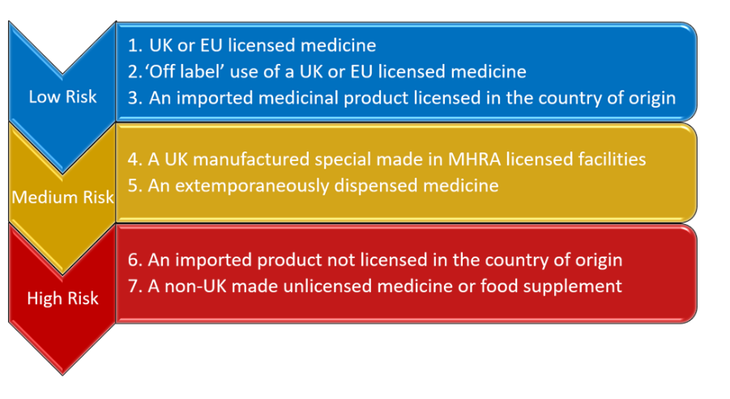
Medical treatment should always use licensed medicines wherever possible, and this is the case for most patients. Please note that the MHRA Guidance Note 14 – The supply of unlicensed medicinal products (“specials”) (Appendix 2) sets out the hierarchy of risk for the supply of unlicensed medicines that should be followed. A simplified diagram of the hierarchy is shown below:
Unlicensed medicines do not have a marketing authorisation in the UK and may not have been assessed by the MHRA. Regulation 167 of the Human Medicines Regulations 2012 allows for unlicensed medicines to be supplied when there are no licensed available medicines that can meet the needs of individual patients.
The needs of individual patients must be clinical in nature and are determined by the prescriber responsible for their care.

How to identify a licensed medicine
It is not always clear if the product you are supplying holds a product license. The Marketing Authorisation number on the outer packaging will take one of two different formats, depending on when the medicine was authorised:
- medicines with a PLGB prefix, for example PLGB/12345/12340, were authorised for the Great Britain (GB) market before 1 January 2025 but are now valid for the whole of the UK
- medicines with a PL prefix, for example PL/12345/12340 have UK-wide Marketing Authorisations.
From 1 January 2025, all UK-licensed medicines must bear ‘UK only’ on the outer packaging.
There may be medicines without ‘UK only’ available on the UK market for a period until their expiry date. If obtained from bona fide sources, these medicines can continue to be used until their expiry date.
For more information, see the MHRA page Labelling and packaging of human medicines following the Windsor Agreement.

