- Install the Omnissa Horizon client from Here. This will produce an .exe file which you will be able to find in your downloads folder.
- Double click on the exe file and select Agree & Install
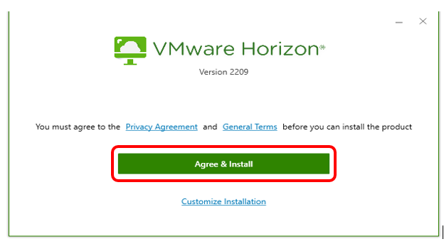
- Once complete click on Finish and then restart the PC.
- Open the VMWare Omnissa Horizon Client you have just installed from the start menu or desktop
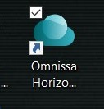
- Click on Add Server
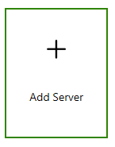
- Add the following into the Name of the Connection Server box - vdi.nhsh.scot.nhs.uk and select Connect
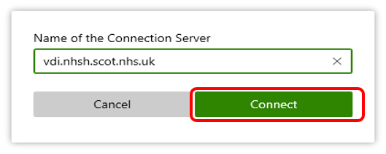

- You may be asked to authenticate with your current M365 account. Following which, you will be presented with the below, select Open, then Accept .
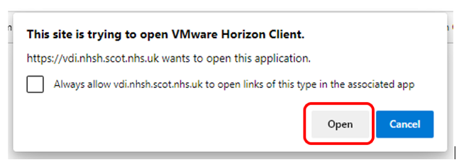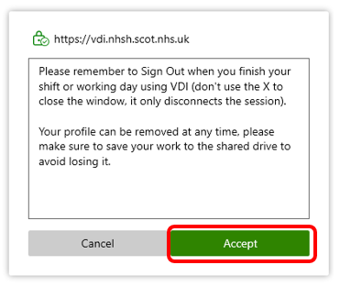
- Once you have accepted you will be presented with the logon screen to access NHSH systems. Enter your NHSH username and password as provided by your eHealth Facilitator and select NHSH from the lower dropdown box. Then click Login

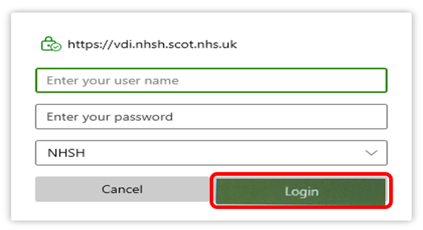
- You will then be presented with VDI desktop/s. Community Pharmacists should select Live – VDI Desktop by double clicking on the icon below. This will proceed to log you into a NHSH desktop.
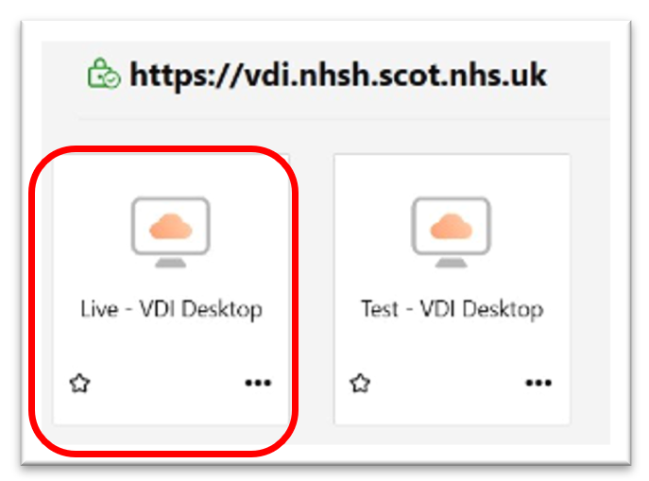
- To open Care Portal, user should double click on the Microsoft Edge icon on the desktop.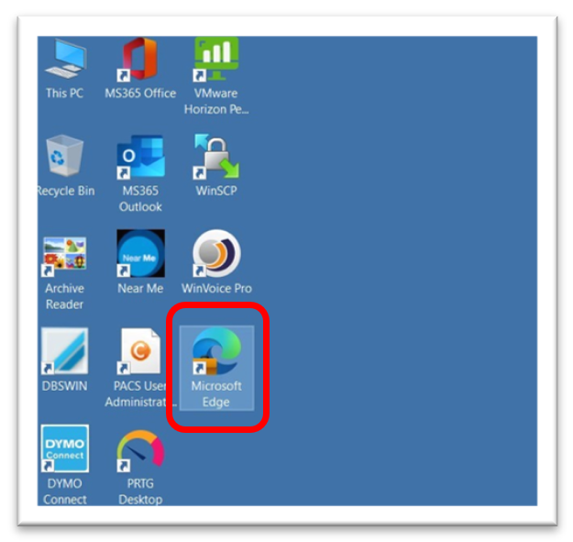

- You will be presented with the NHSH intranet, scroll down and double click on the NHS Care Portal nugget
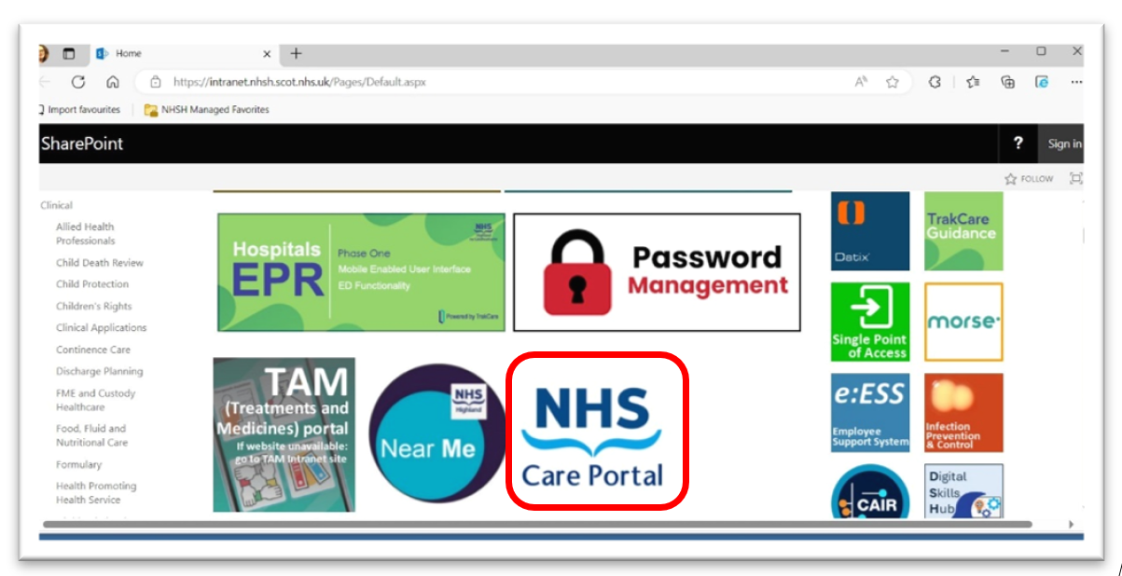
- Currently you will see a system message as below, click Continue.
Please note this can take up to 3 minutes to progress to the next screen
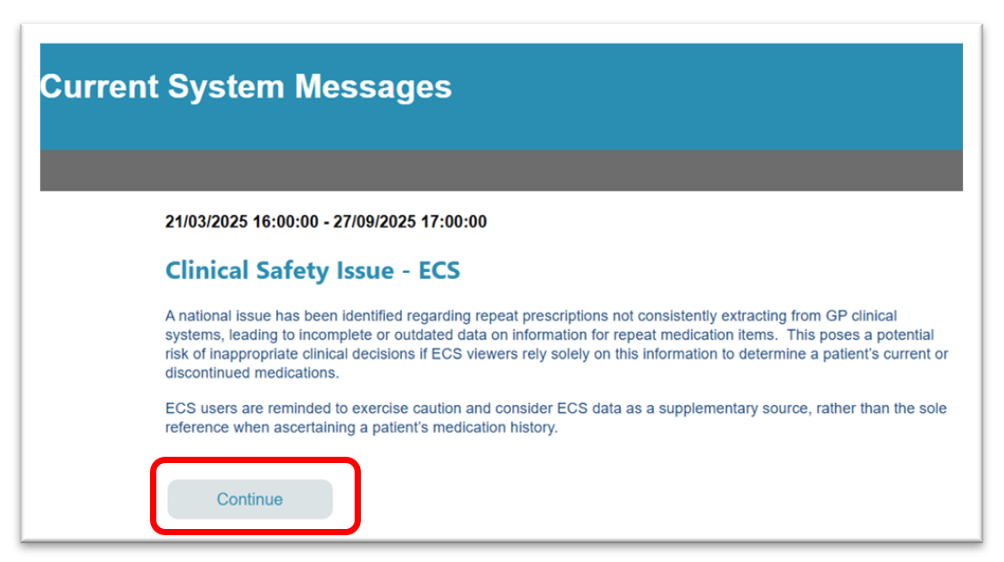
If the following message appears, click OK to continue
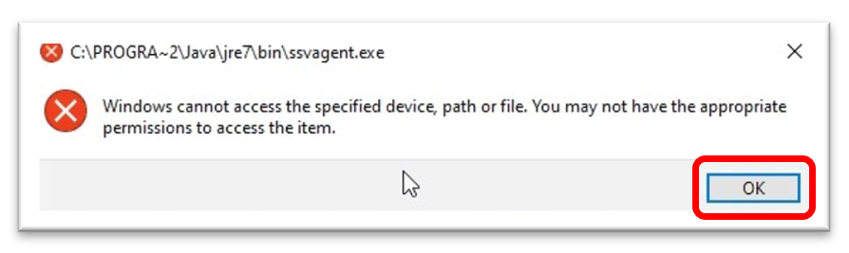
- On the Care Portal login screen select your Organisation and complete your User ID and Password which will be provided to you by your NHS Board. Click Login to proceed.
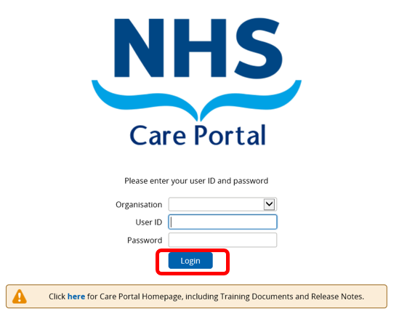
- When finished using Care Portal, logout using the Logout button on the top right hand side and close down the browser containing Care Portal
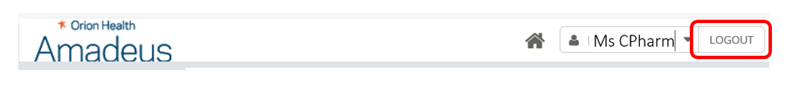

- You must fully exit the VDI desktop when Care Portal is not in use.
To logout of the VDI desktop, click on the 3 ellipses on the top right hand corner and select Logoff Desktop
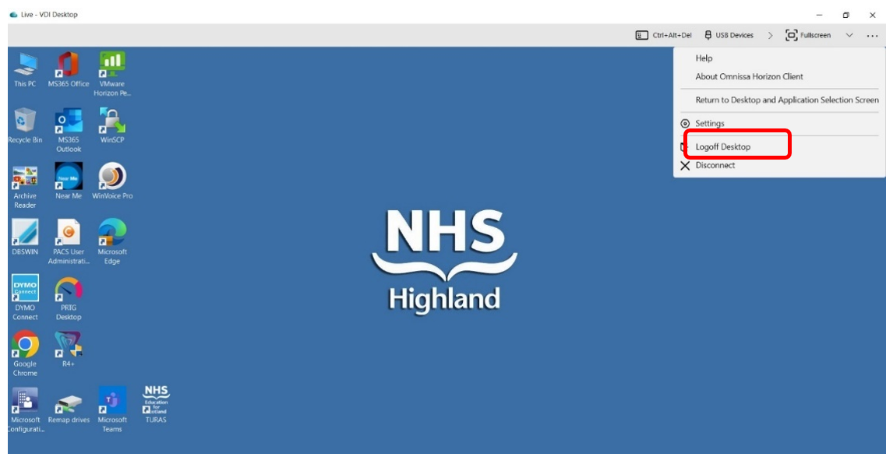
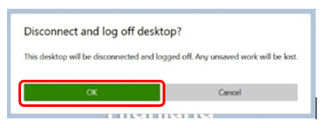
- Having closed down the VDI Desktop, you must now disconnect from the Omnissa Horizon Client Server. Select Disconnect from the bottom left and click OK.
