Clinical Portal Access Request Form
V2 March 2025

Name of Pharmacy | Address of Pharmacy
Postcode | Pharmacy Contractor Code
Telephone Number | Email address (of Contractor/Area Manager/Superintendent)
IMPORTANT NOTE: Practices must provide their IP address to gain access to Clinical Portal. Please refer to Page 2 for instructions on how to find this. | IP Address of PC/Laptop

Please print/type clearly first name, surname, job title, email address and GPhC registration number of staff who you wish to be given access to Clinical Portal

First Name | Surname | Job Role | e-mail address | GPhC No

I hereby confirm that the above named require access to Clinical Portal.

All eligible staff must be signed off below by the Contractor, Area Manager, Superintendent or Pharmacy Manager that has the authority to sign off on behalf of the company.
Please note we require a wet signature; digital or typed signatures cannot be accepted.

Signature: ___________________________ Date: _____________

Print Name: __________________________ Designation: _________________________

Please return completed form to:

NHSLanarkshire.PharmacyFacilitation@lanarkshire.scot.nhs.uk

How to find your IP address

On a PC/laptop which you use to access NHS services via the CAT20, click on the search bar and type cmd, right click on “cmd.exe App” and click -run as administrator.
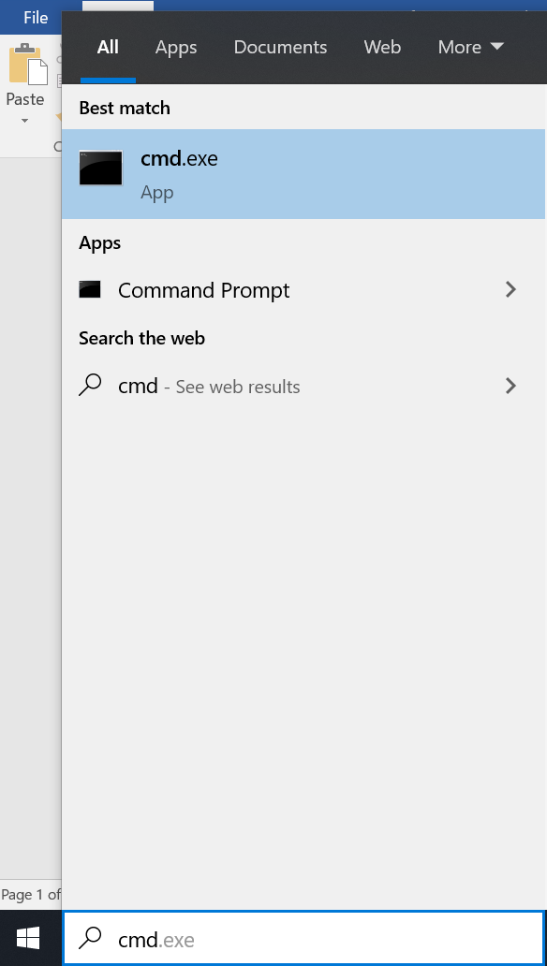

Say Yes to the message “Do you want to allow this app to make changes to your device”

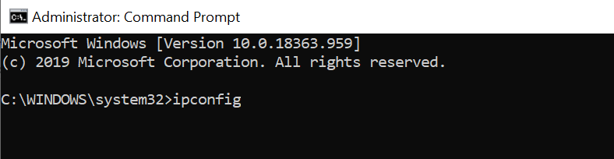
Type ipconfig then press enter.
Your IP Address is identified as highlighted below in red (IPv4 address)
Note this is an example-yours will be a different IP address
