Community Pharmacy Lanarkshire
Pharmacy First Plus Newsletter
february 2026

Prescribing Data – February 2026
The Pharmacy First Plus service is available across 60% of NHS Lanarkshire’s Community Pharmacy network. In February there were 94 active prescribers.

Locality | No. IPs
Airdrie | 12
Bellshill | 11
Camglen | 19
Clydesdale | 15
Coatbridge | 10
East Kilbride | 12
Hamilton | 12
Motherwell | 9
North Locality | 9
Wishaw | 13
Total | 122

Have you moved to a new pharmacy site or healthboard?
You must notify the NHS Lanarkshire Pharmacy Admin team of any changes to your workplace/practice or if you leave the organisation:
- If you move to another contractor code within NHS Lanarkshire you must notify Pharmacy Admin of the new contractor code to ensure the IP organisational data base is accurate. NHS Facilitation must also be notified to ensure your NHS mailbox, Clinical Portal and Emergency Care Summary access reflects this.
- If you move to another sector of practice and/or another health board, you must notify Pharmacy Admin and destroy any prescribing pads issued by the health board (an email from your line manager confirming pads have been shredded and disposed of into confidential waste is sufficient). Similarly, any prescriber joining the health board must apply for an NHS Lanarkshire prescribing number and must not use any other number issued by previous employers. NHS Facilitation must also be notified to ensure your NHS mailbox, Clinical Portal and Emergency Care Summary access reflects this.
Your NHS Lanarkshire prescribing number and prescription pad is for use within NHS Lanarkshire only. These pads cannot be used / annotated by another prescriber.
Areas out with PF+ Service
The Pharmacy First Plus Service should be provided when an individual presents with symptoms of a common clinical condition(s) which is beyond the scope of the standard NHS Pharmacy First Scotland service and within the prescribers’ competence to prescribe and manage. Recent prescribing reports have shown an increase in prescribing for several conditions that do not fall under the scope of the Pharmacy First Plus service:
- period delay
- erectile dysfunction
- Vaccinations
- Urgent access to medicines
- Items of low clinical value
It should also be noted that we have seen an increase in NRT products, Varenicline & Levonorgestrel/Uripristal being issued via the Pharmacy First Plus service; please remember smoking cessation & Emergency Hormonal Contraception sits under the Public Health Service section of the national contract not Pharmacy First.
Acne
A reminder that Doxycycline is the preferred antibiotic of choice, not Lymecycline, please follow the West of Scotland Formulary, snippet below.
Mild - Moderate | First Line: Benzoyl peroxide+Clindamycin OR Clindamycin+Tretinoin OR Adapalene+Benzoyl peroxide  Second Line: Benzoyl peroxide  Third Line: Adapalene OR Trifarotene  Fourth Line: Erythromycin+Zine acetate
Moderate - Severe | First Line: Adapalene+Benzoyl peroxide + Antibiotic  Second Line: Azelaic Acid + Antibiotic  Third Line: Co-cyprindiol  Fourth Line: Spironolactone  Oral doxycycline is the preferred antibiotic. Lymecycline should only be used if there are issues with doxycycline (e.g. photosensitivity). Erythromycin can be used if contraindications/intolerances to tetracyclines.
Severe | Specialist Initiation Only - Isotretinoin

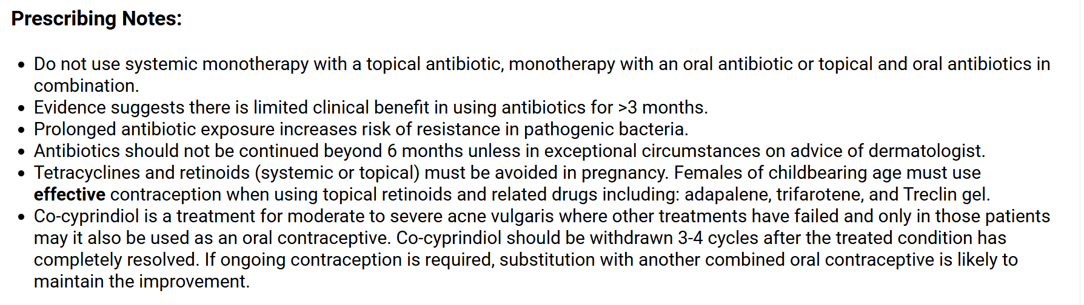
Skin Inflammation
There has been an increase in Hydrocortisone 0.5% cream, costing £88.00 per supply. This is not on formulary. When prescribing steroids, please follow the West of Scotland Formulary, snippet below.
Mild | Hydrocortisone 1% cream / ointment
Moderate | Clobetasone 0.05% cream/ointment (30g most cost effective, if 100g required then Betamethasone 0.025% cream/ointment is more cost effective)
Potent | First Line: Betamethasone 0.1%  Second Line: Flucinolone acetonide 0.025% or Mometasone 0.1%

Monthly Prescribing Governance
As part of NHS Lanarkshire's routine clinical governance processes, the Board undertakes a structured monthly analysis of prescribing activity within the Pharmacy First Plus service. This review is designed to ensure safe, effective, clinically appropriate and cost effective prescribing across all practitioners.
Each month, NHS Lanarkshire reviews prescribing data taking the following criteria into account:
- Items of low clinical value / should not be prescribed in NHS Lanarkshire
- Adherence to the NHS Lanarkshire Formulary
- Adherence to PF+ service specification
- Prescribing of high cost meds
- Prescribing of unlicensed medicines
- Prescribing of specialist initiation only medicines
- Prescribing of controlled drugs

As well as taking the above into account when prescribing on your CPIP pad, prescribers should also consider:
- Am I prescribing in response to a presenting symptom(s)?
- Is the Common Clinical Condition within my scope of practice?
- Are there any mechanisms already available that would enable supply to the patient? E.g. CPUS

West Region Formulary
All prescribing should adhere to the West of Scotland Formulary where products have been selected on the basis of clinical effectiveness, cost effectiveness, comparative safety and patient acceptability. Chapters that are currently live include:
- Gastro-intestinal
- Respiratory
- Cardiovascular
- Skin
User guide videos are available to learn about the features and layout of the website and app.
The next chapters due to launch/go live in (eta) August are:
- Endocrine
- Infections

